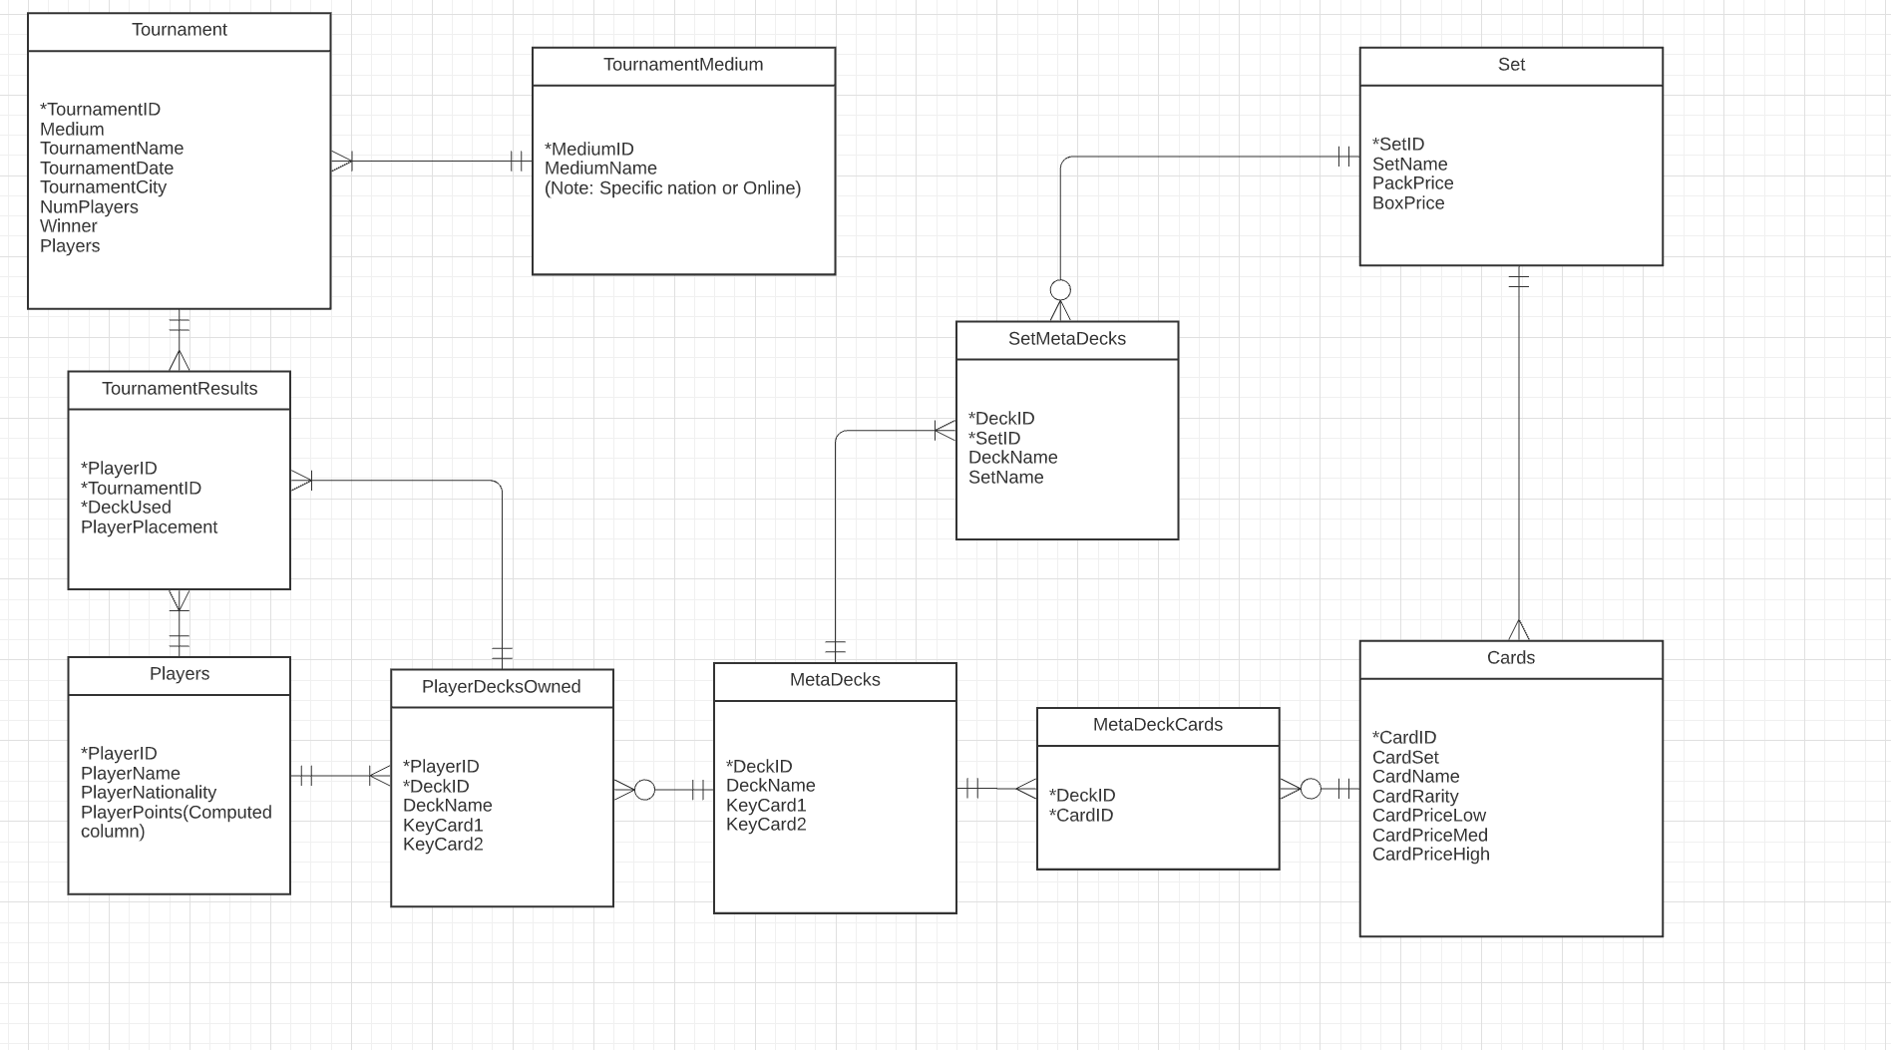

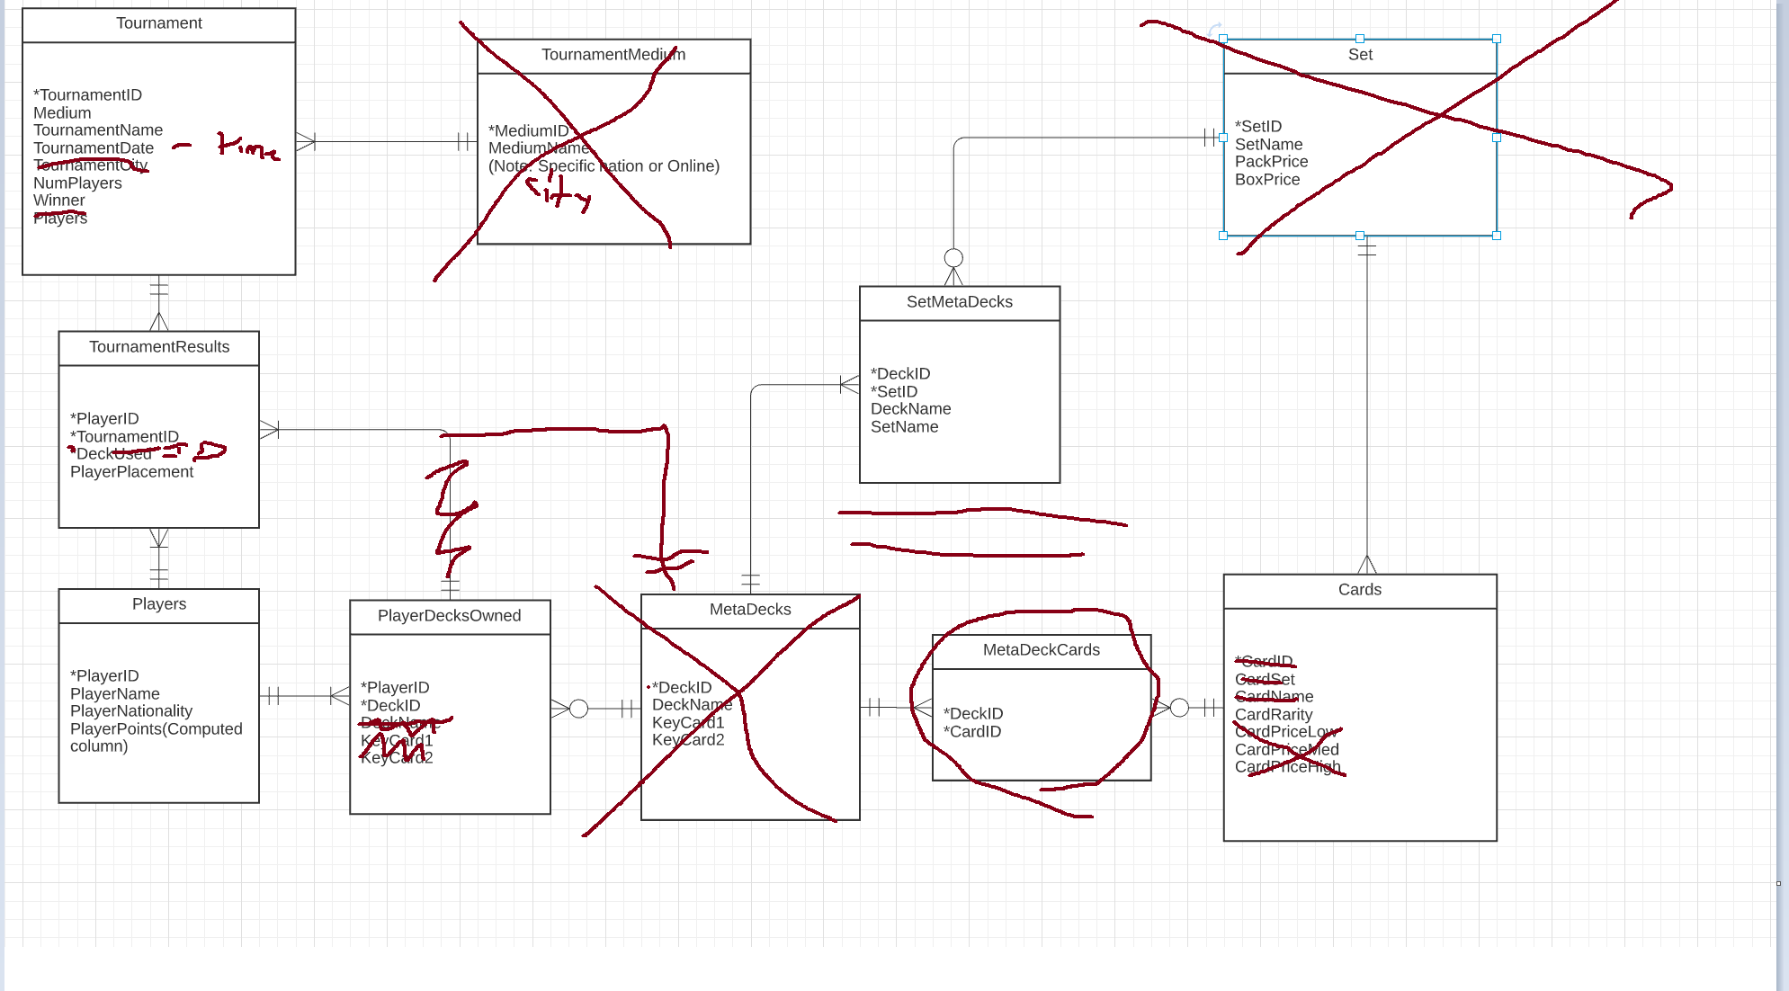

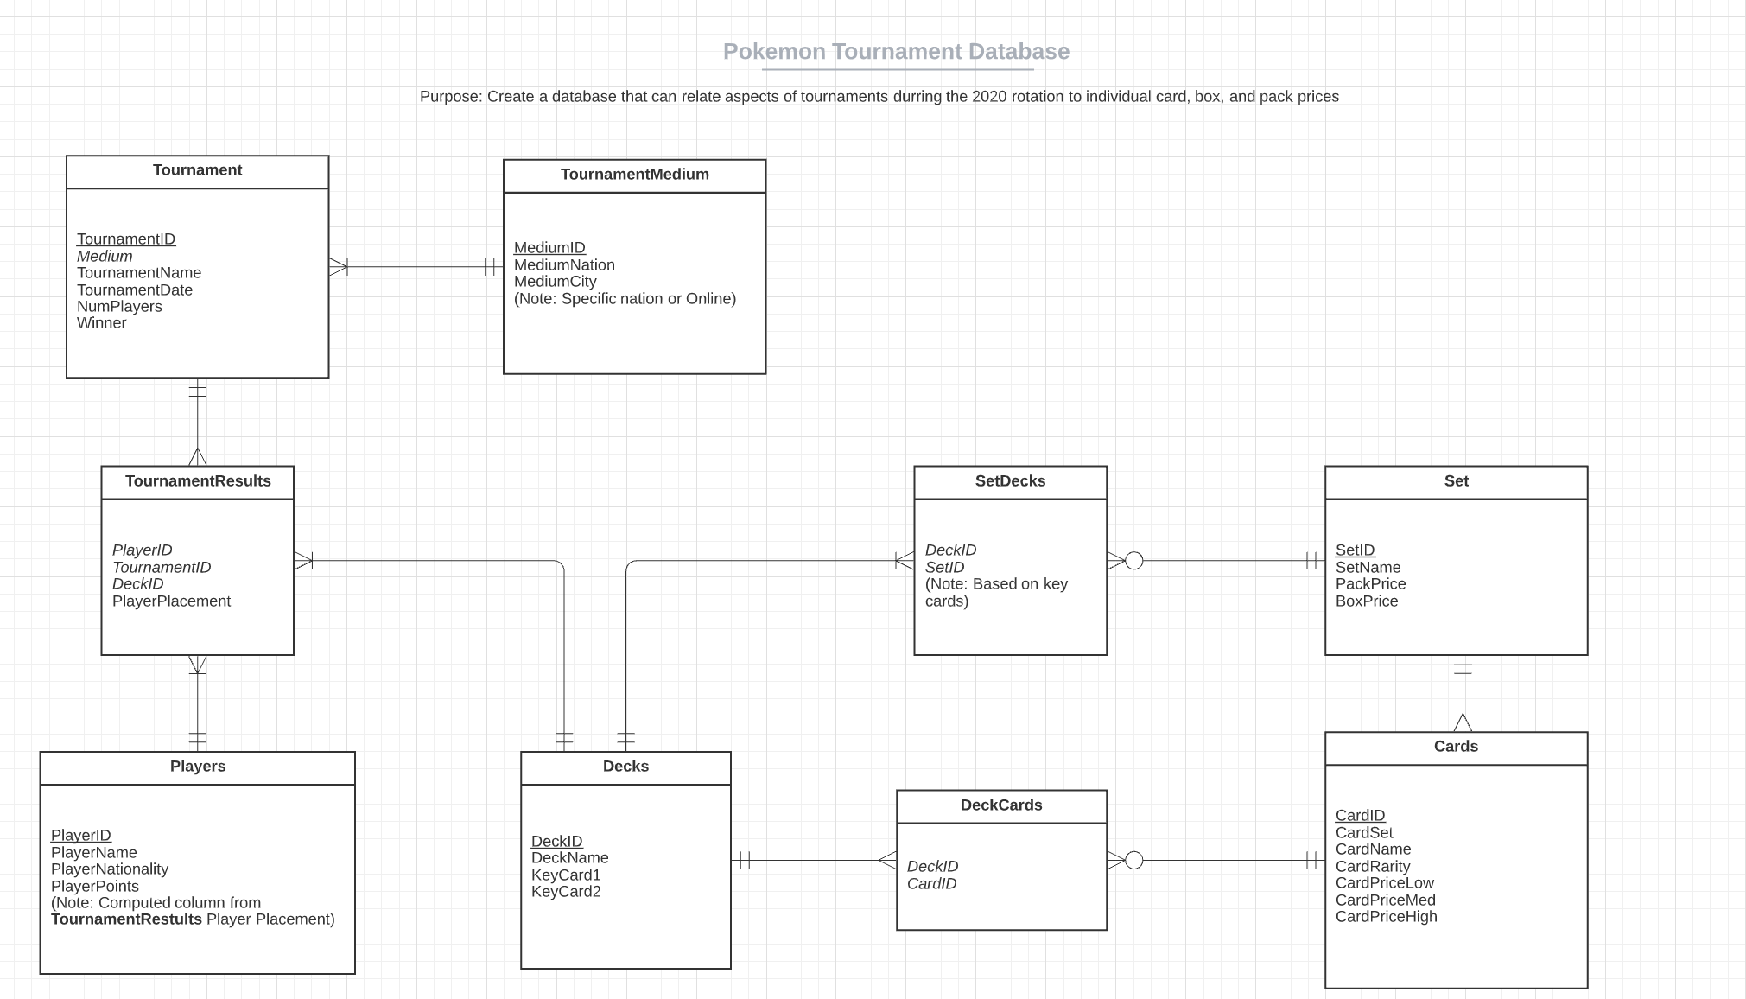

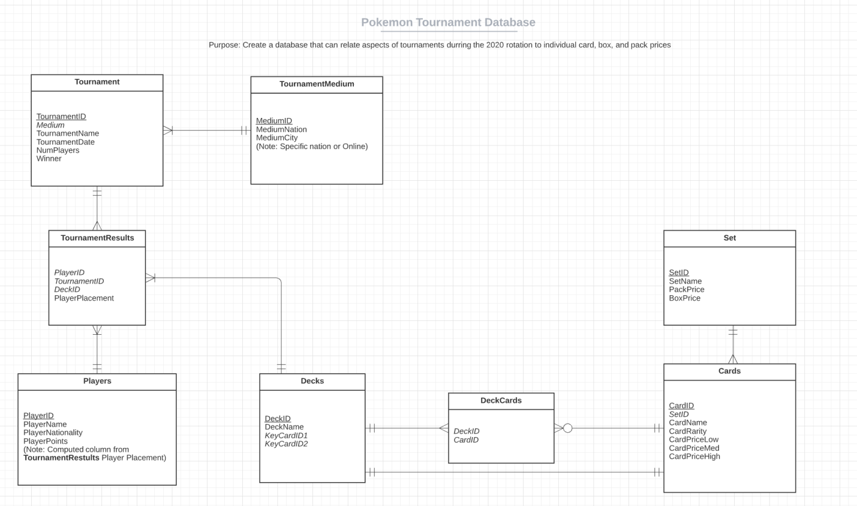

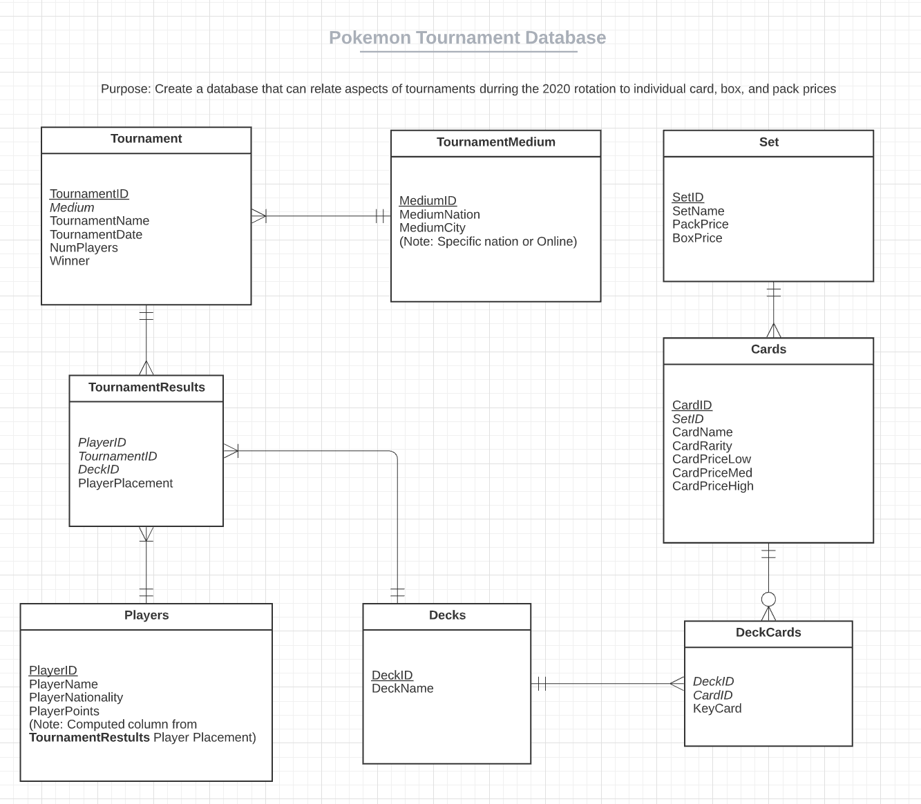

Hello,

Thank you for taking time and interest in my portfolio project. In this document I will be listing out the steps in which I took to recreate a Pokemon TCG tournament/card/deck/player database from https://limitlesstcg.com/ into a recreational database on Microsoft SQL Server. These include: data scraping, data transference, transference data error correction using queries, normalization of the database, analytics done, and the creation of stored procedures. Here I will also discuss all of the difficulties I had throughout the development of the project and the solutions I found to overcome them.

The first step involved in the creation of my database was identifying what functionally I trying to accomplish. Without having a clear goal in mind there would be no way for me to create a game plan for my database using an ER diagram, let alone know what data I needed. Fundamentally, I wanted to recreate an already existing database, but because of the scope of a commercial project, I being just one man, and realizing the large amount of data that would be needed and readily available, I needed to set specific goals for myself and focus more on how I could improve upon what already existed as well as how I could use my new database for analytical purposes. After an extended amount of time noting what the “Limitless” database had to offer I decided to focus my attention on the monetary aspects of the game and the how tournament results had an impact on card, box, and pack prices.

Once again to scale down my project instead of trying to acquire all data from the existence of the game in 1996, I decided to only look at the 2019-2020 rotation of the game. For those who do not know what a rotation is, fundamentally card games release sets of cards constantly, around four sets per year. To keep the game fresh, tournaments only allow cards to be played from a specific number of the most recent sets. In the 2019-2020 rotation, that included fourteen sets, each with around 80 to 130 cards. From these sets players will make ever evolving decks as the tournament season progresses. When a new set is released what was once good, suddenly isn’t and the results and decks played reflect this. This rotation selection meant that I would need to acquire tournament, player, and card data from only the past year. I would also need some way to identify what decks were actually being played to relate what was good and played to the value of those cards and the sets they were in.

Now knowing my quarry, my data hunt began.

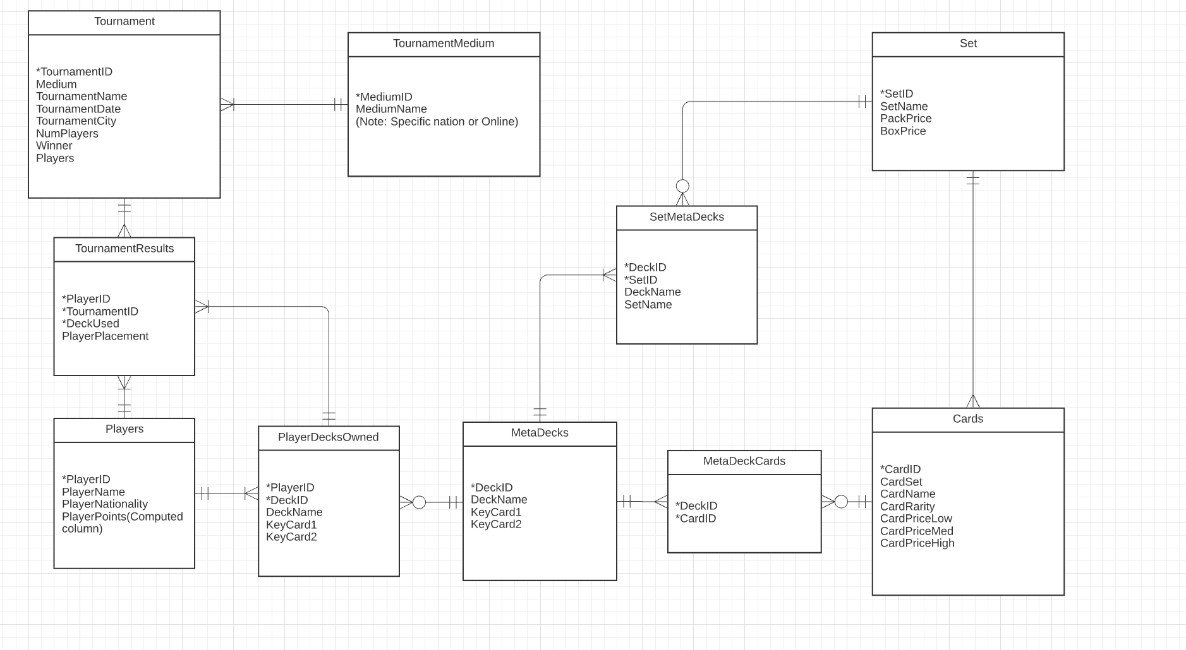

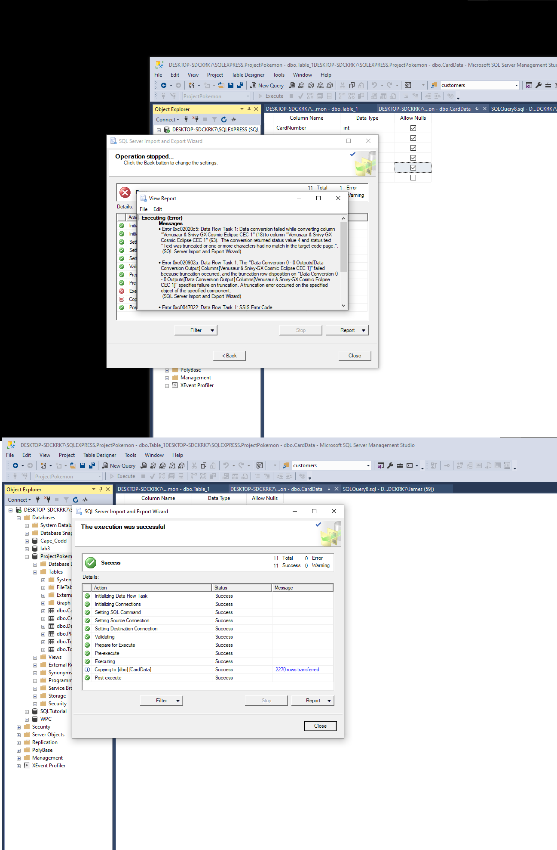

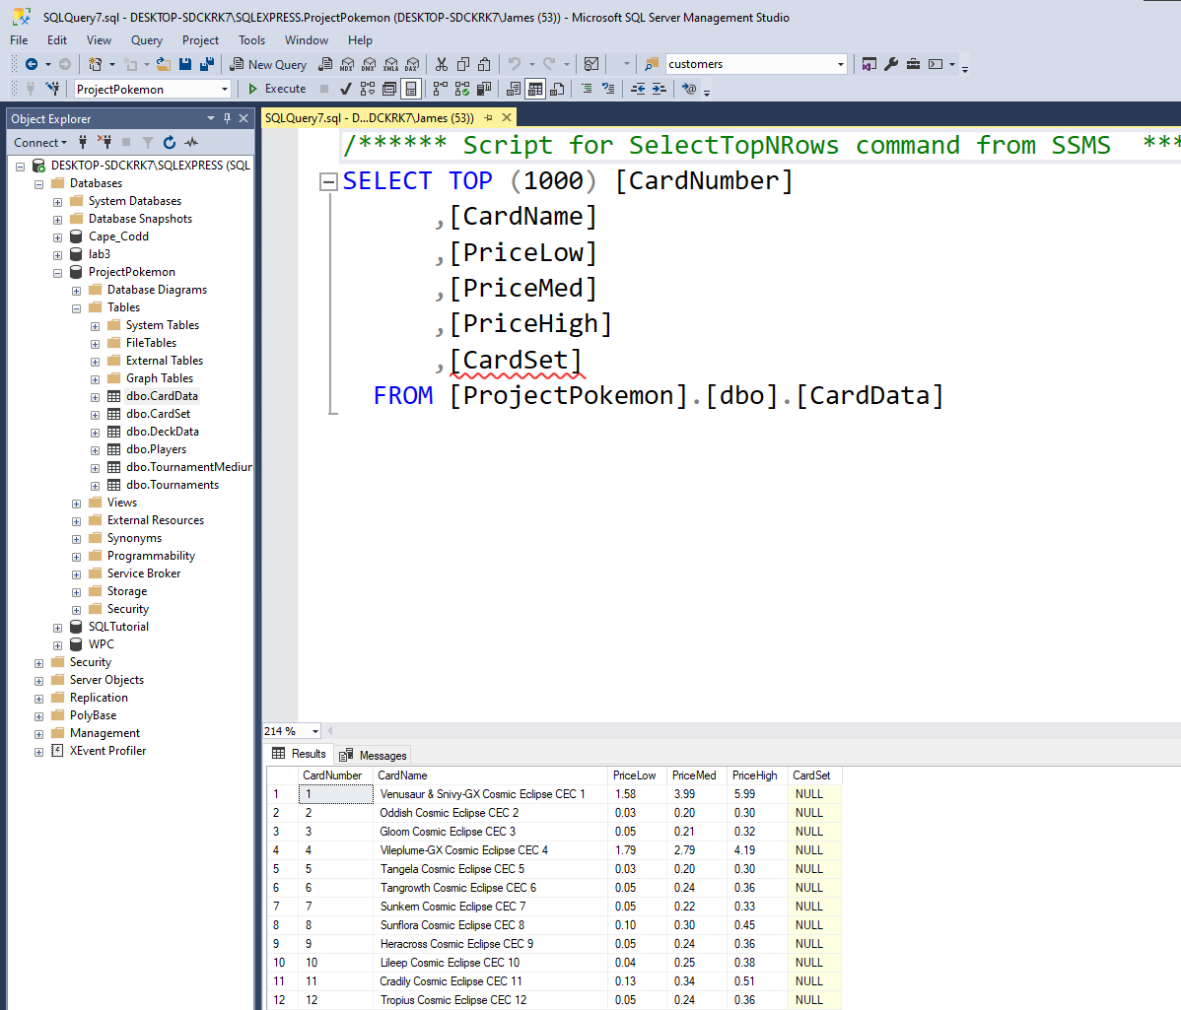

I intentionally created an empty column to be used in the future as a foirgn key that becomes a composite key for this table set and card number need to create query to update missing and then make stored procedure using it, for when inserting new data the column is always based on what is in the CardName String

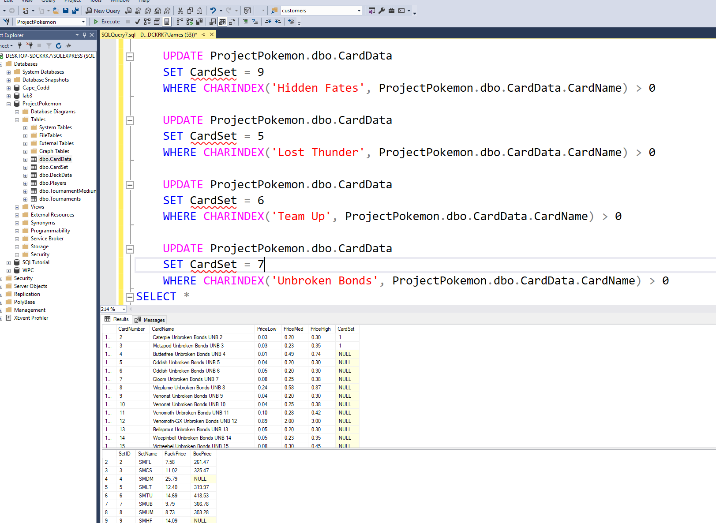

I wanted to update it with a changing variable but I learned that

Subquery returned more than 1 value. This is not permitted when the subquery follows =, !=, <, <= , >, >= or when the subquery is used as an expression.

Once again I feel I could have done this with loops but I have been told that is bad practice.

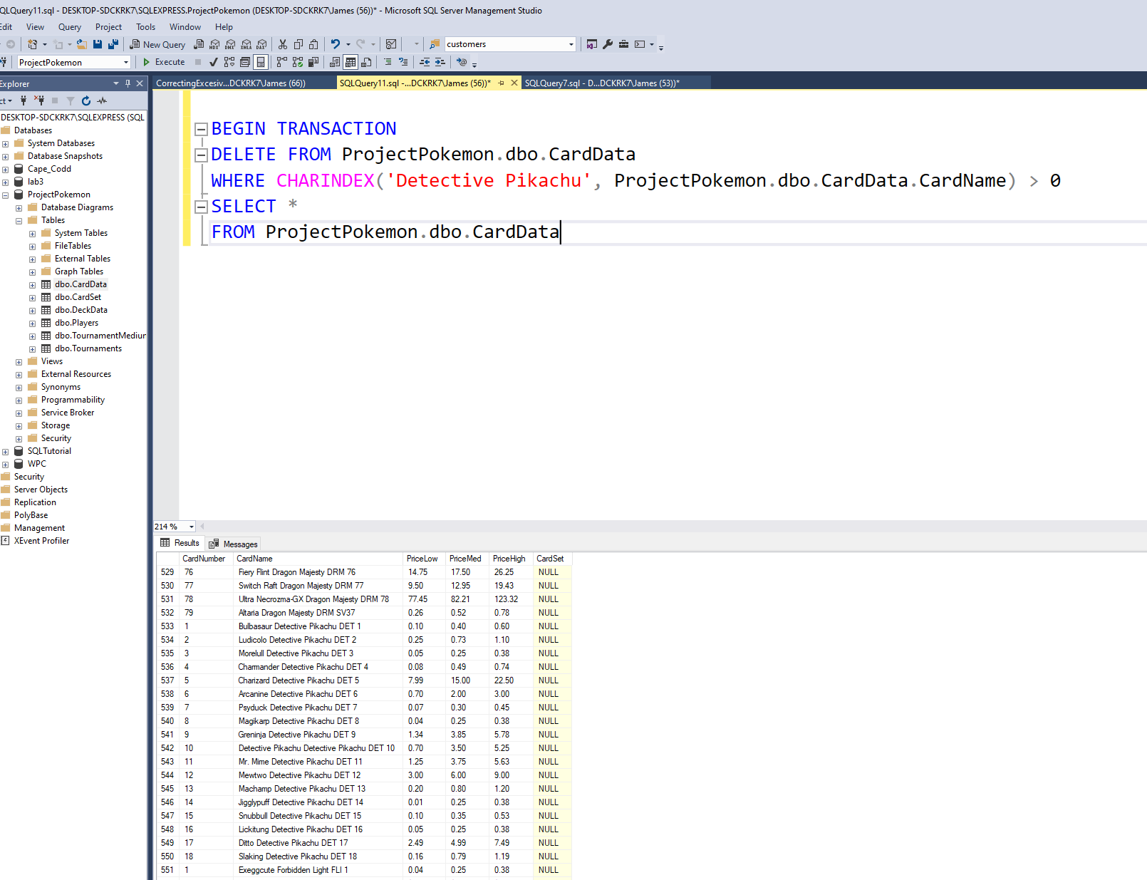

Found and removed more eronious data, I added in Detective Pikachu information which is unneeded as the promos have no use.

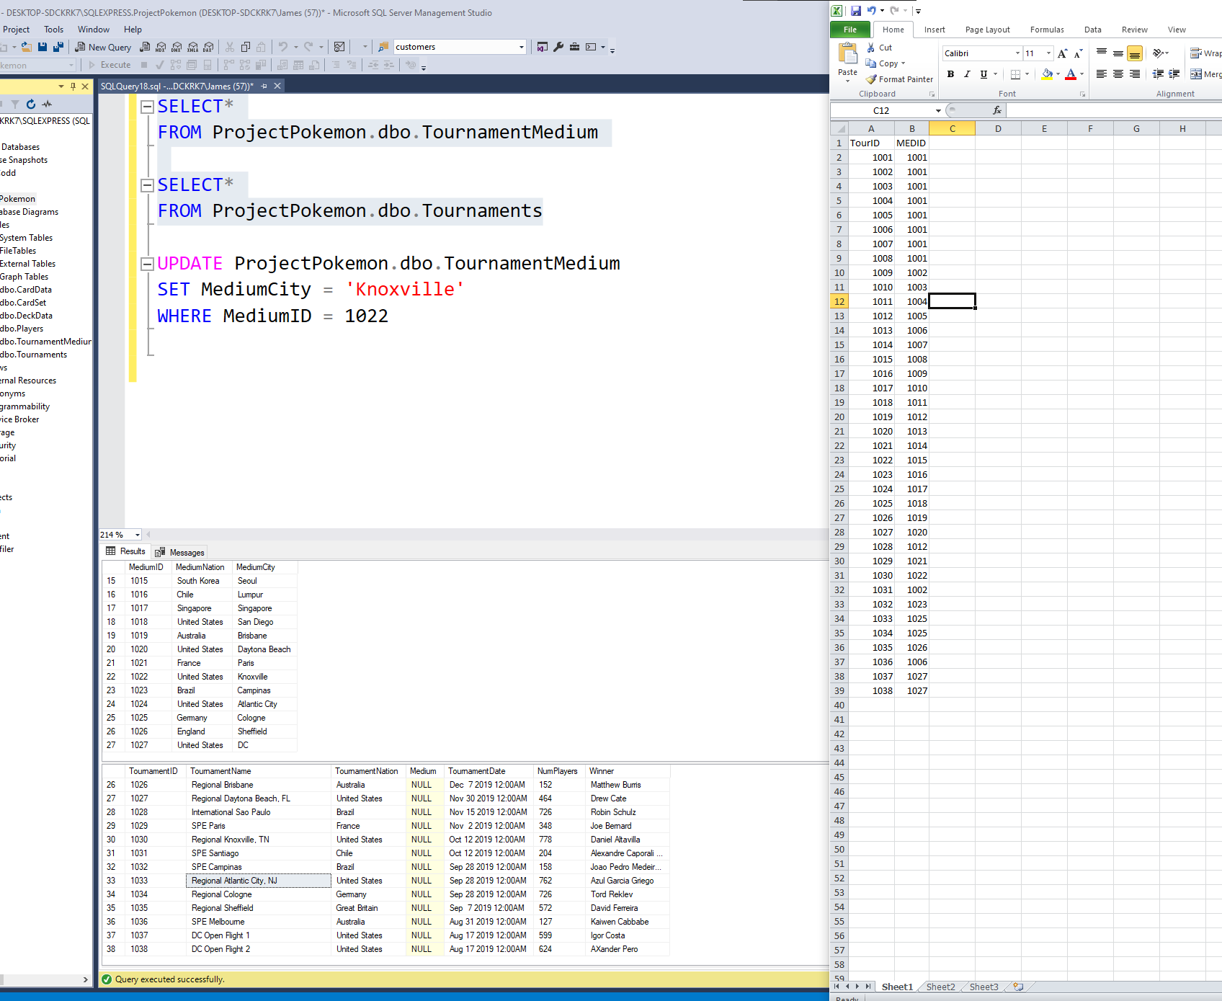

Making corrections and updating missing info to use as forign key

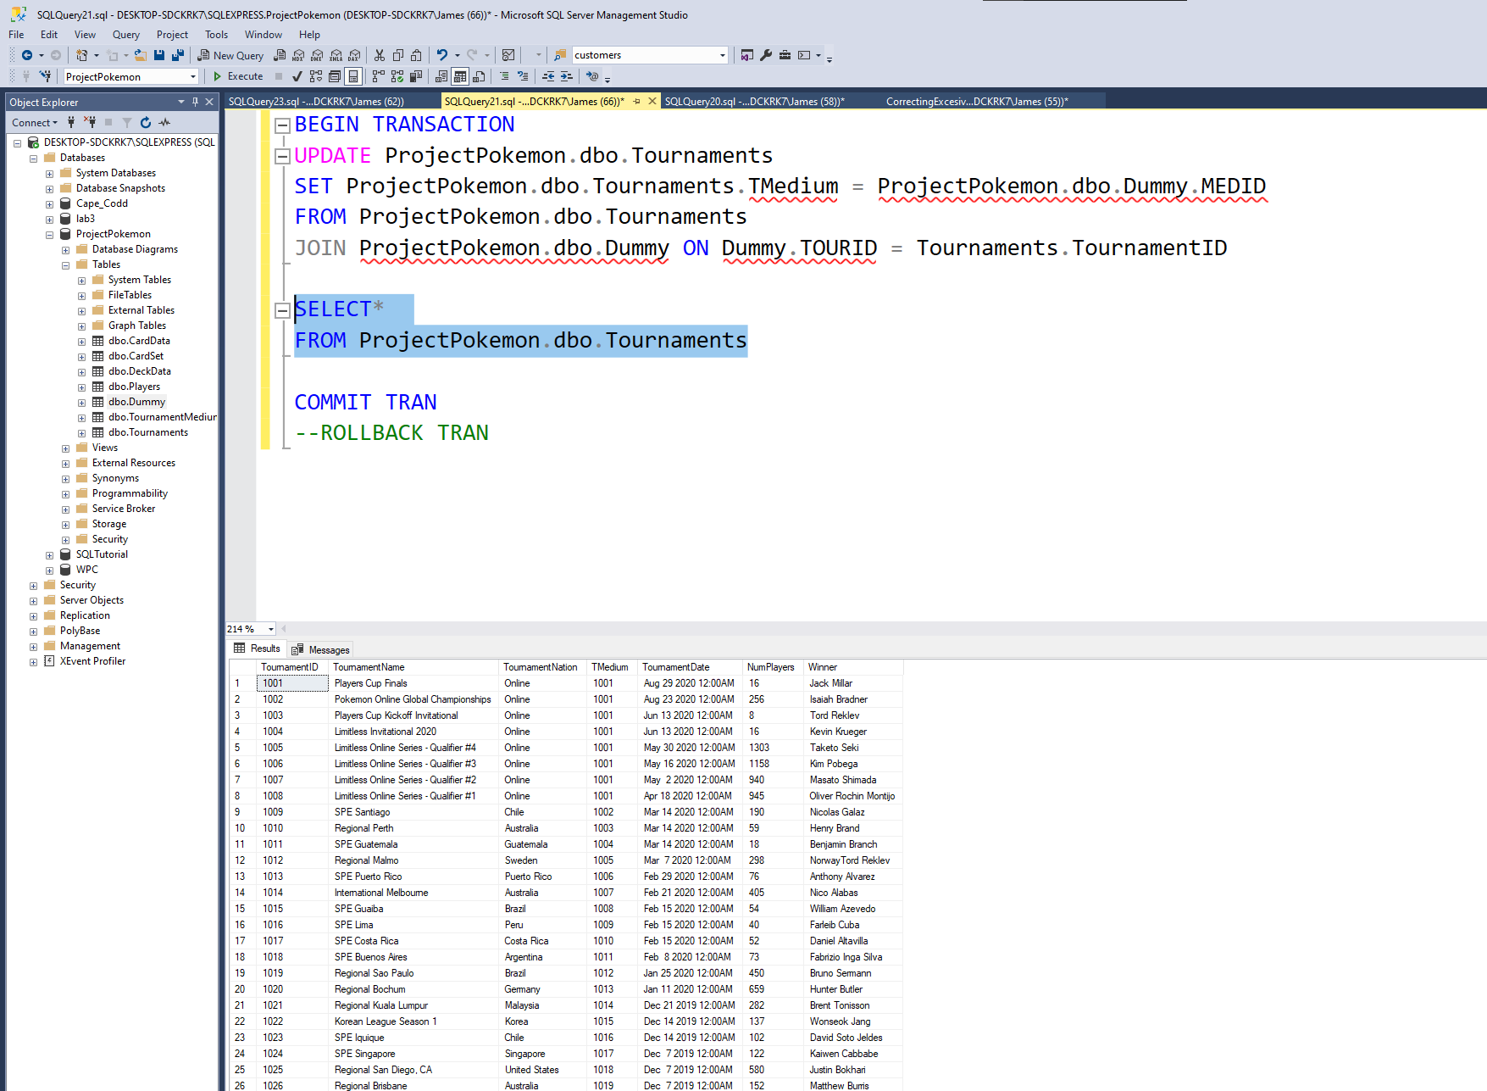

Inserting using a dummy table

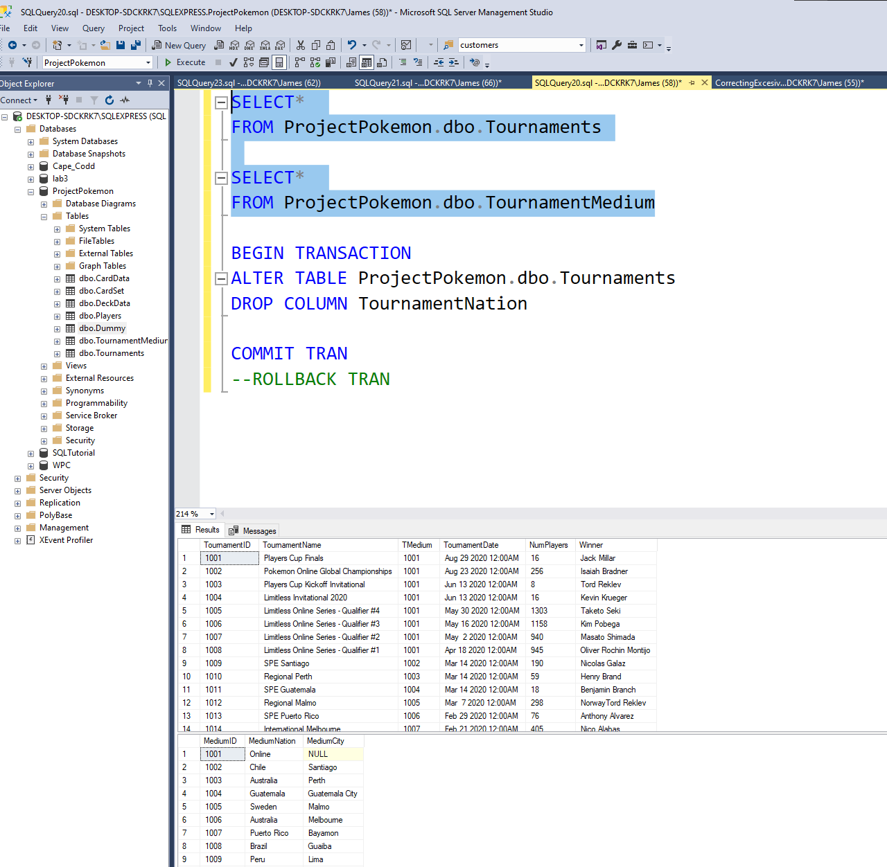

To normalize my data tournament nation data was eronious for the tournament section as it will be attached as a fogirn key to tournament medium who already has that data and more location data.

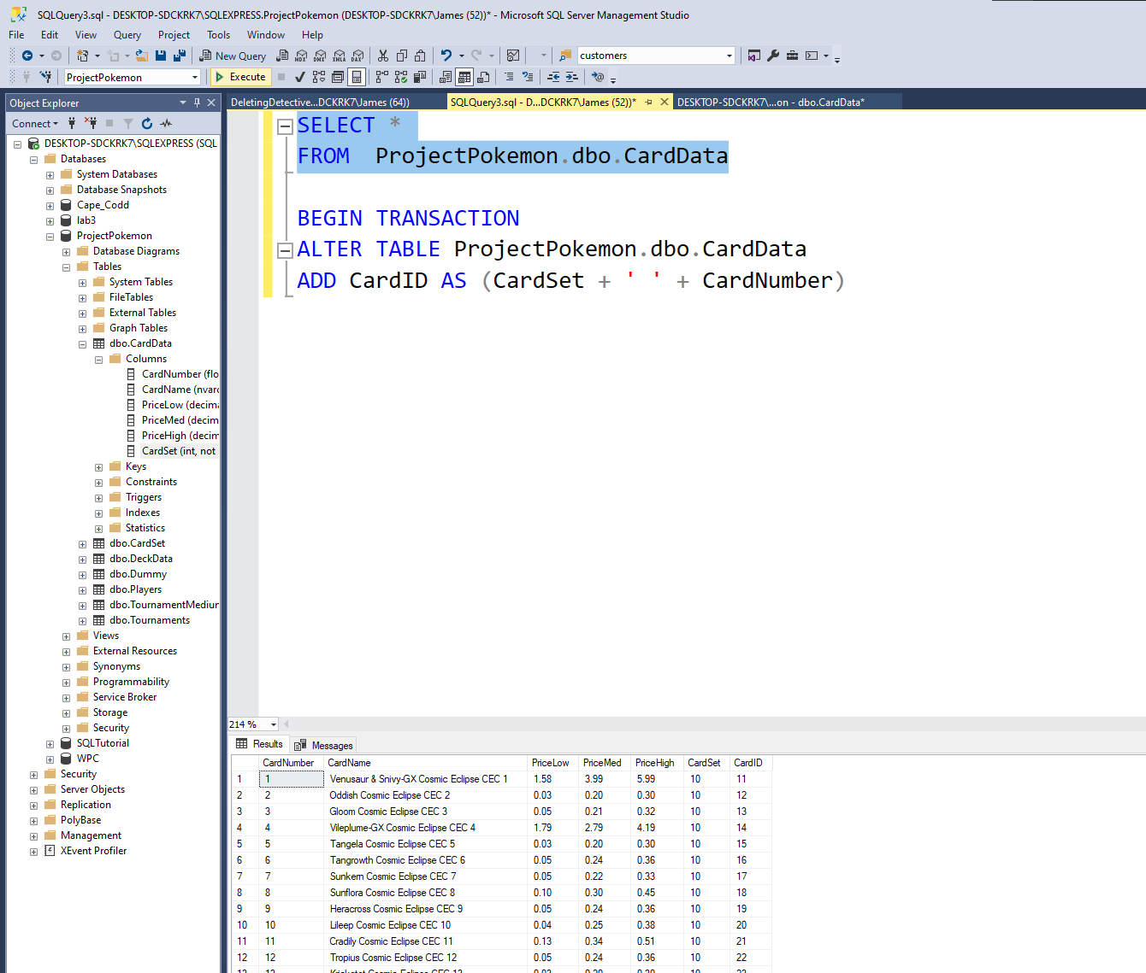

Creating a compound foreign key failure.

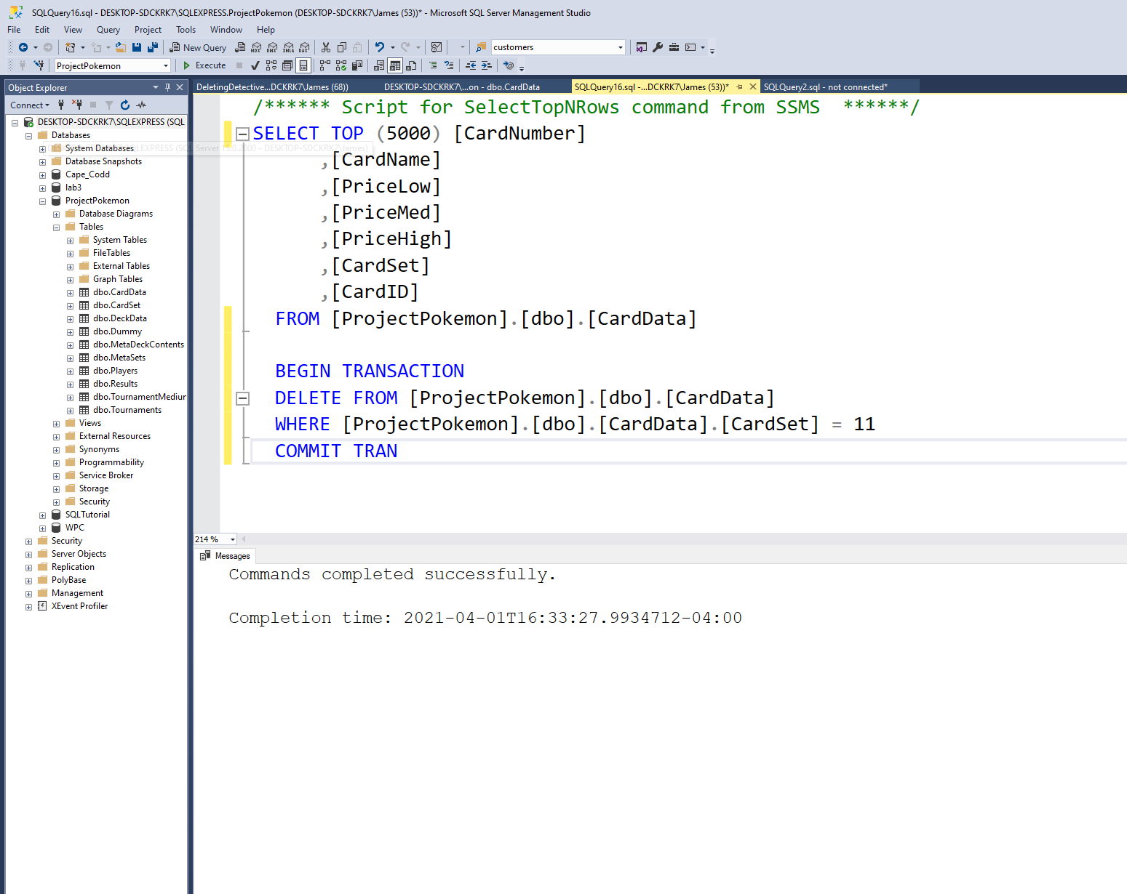

Accidently added large amount of data twice as different set, needed to remove it

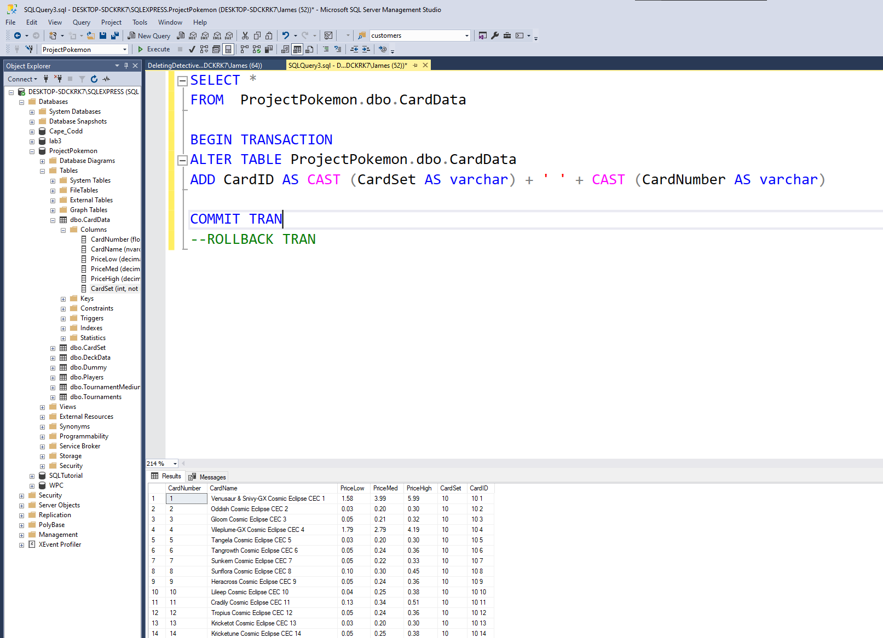

Creating new primary key as a compound column by casting card number and card set as a varchar

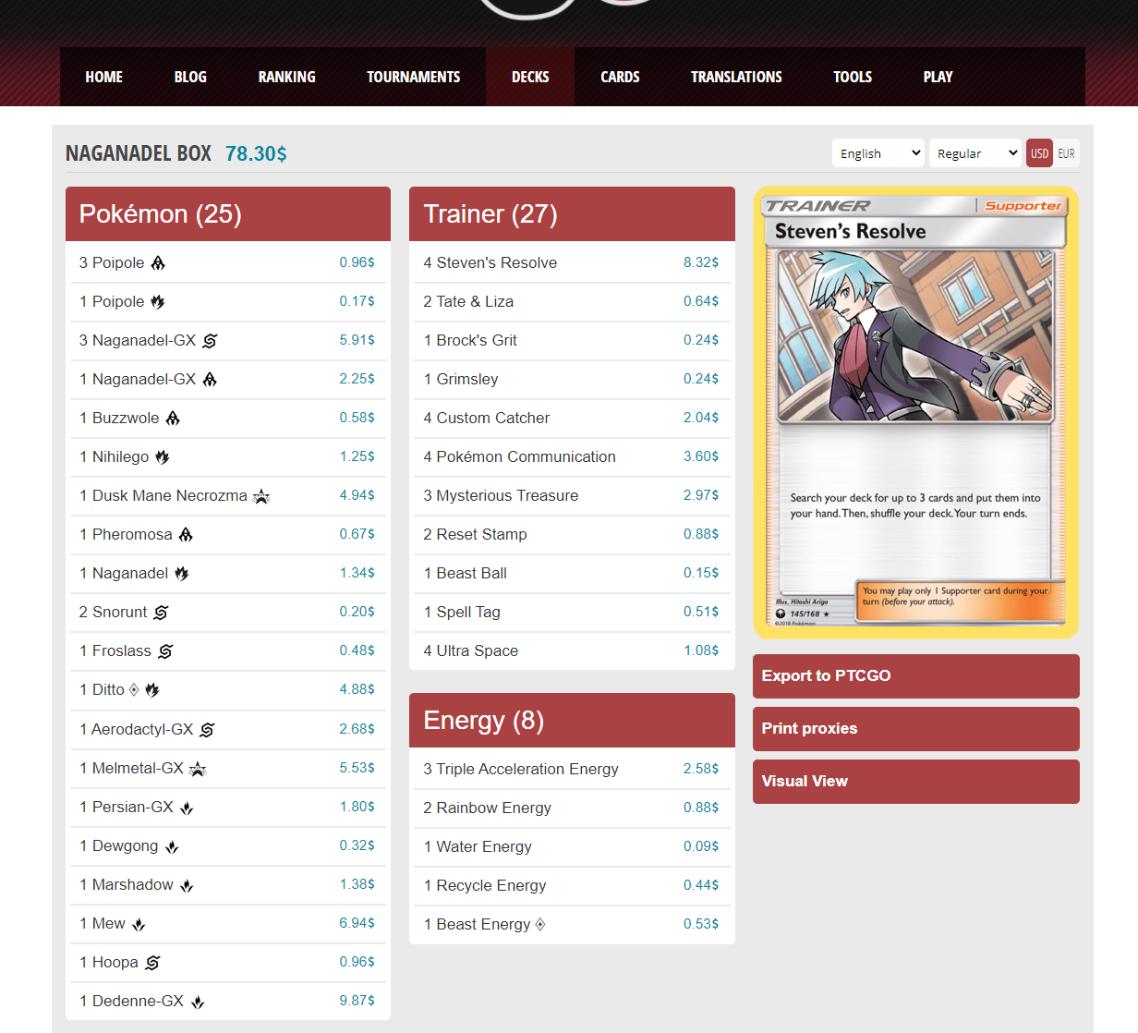

An improvement of my DB is that you can see and look up cards set and card ID which this DB doesn’t provide and in the deck list we can look up these values when this DB doesn’t even have visuals for trainer and energy cards for their set or number

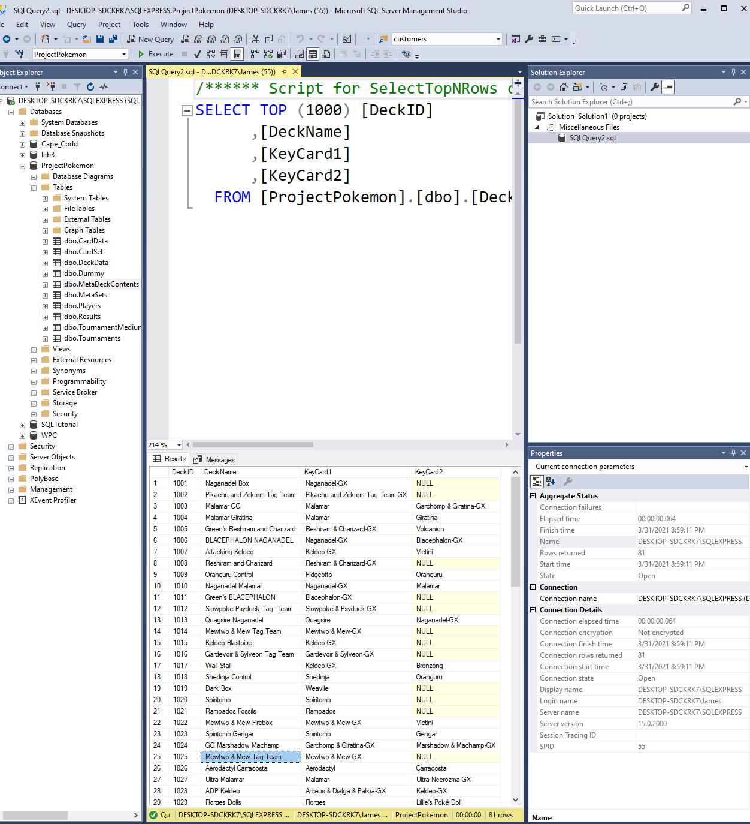

Mew2 and Mew tag team in twice, need removal

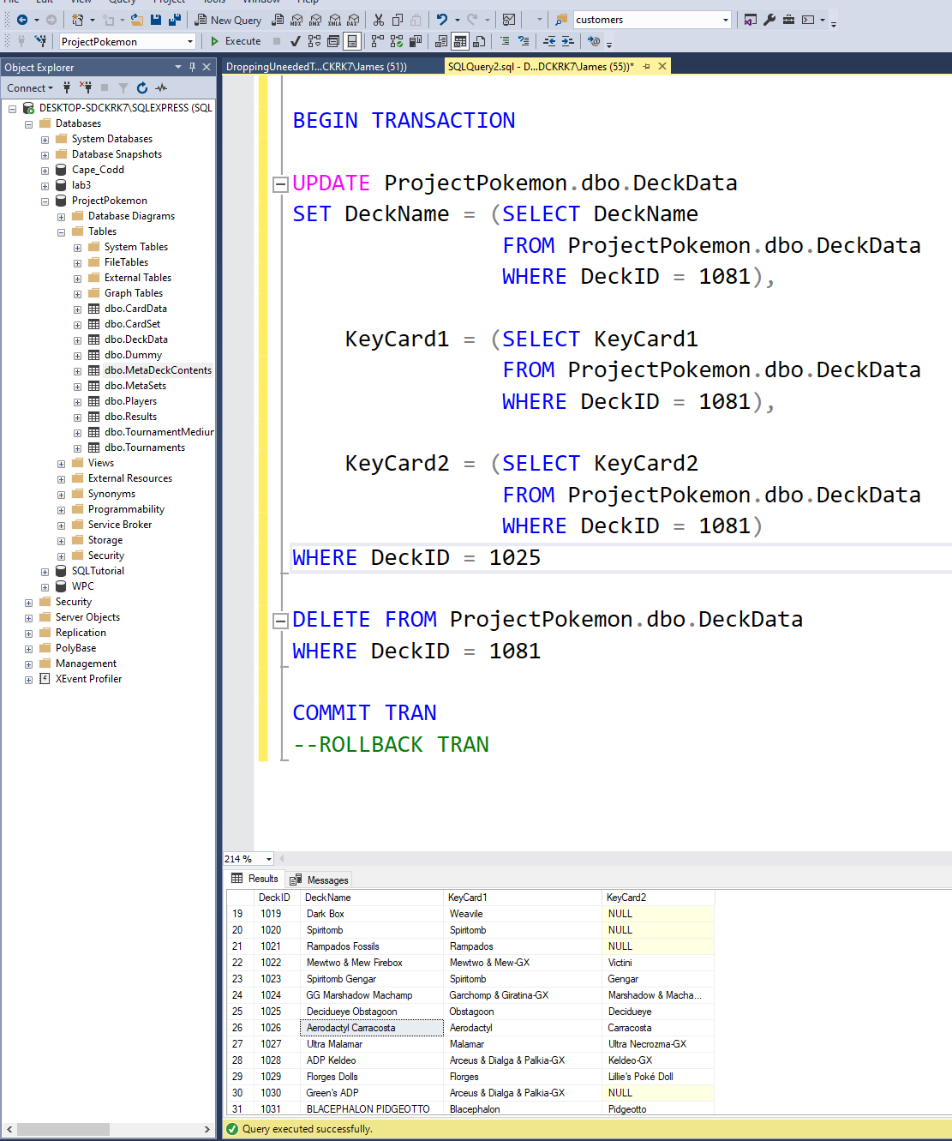

Fixed and would make a good update stored procedure

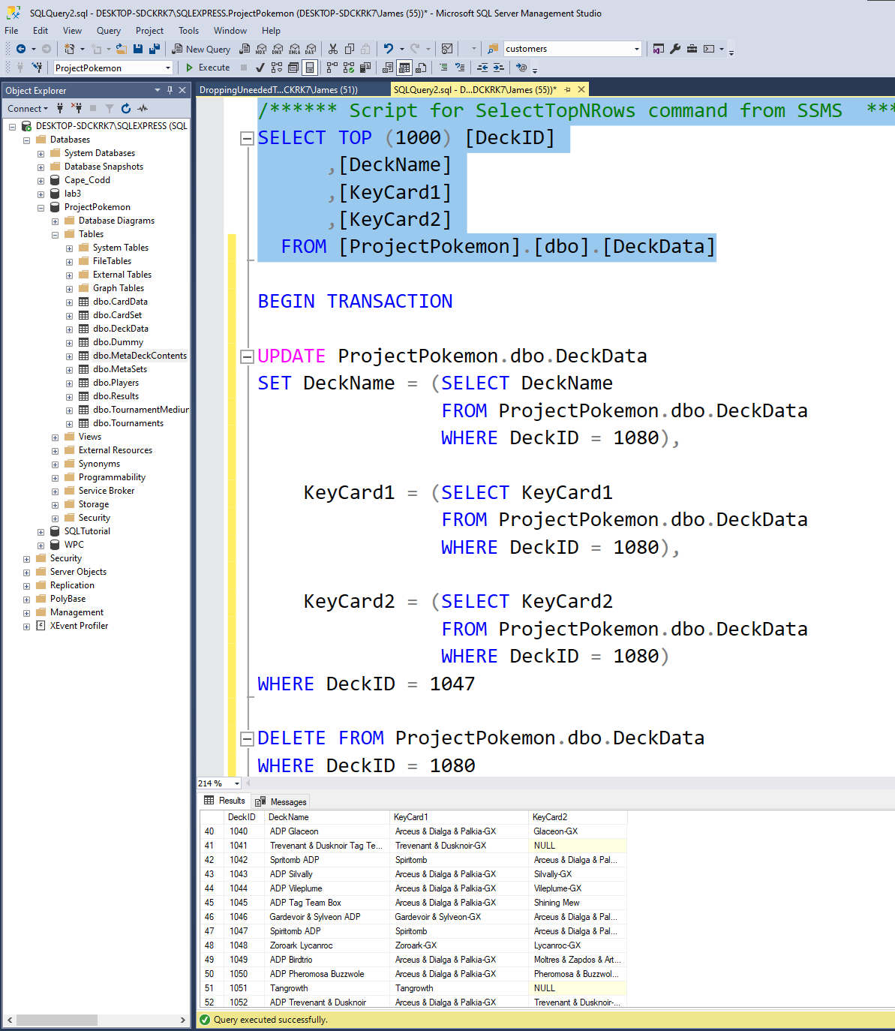

Found another with Spritomb adp couple changes to code to remove and swap too.

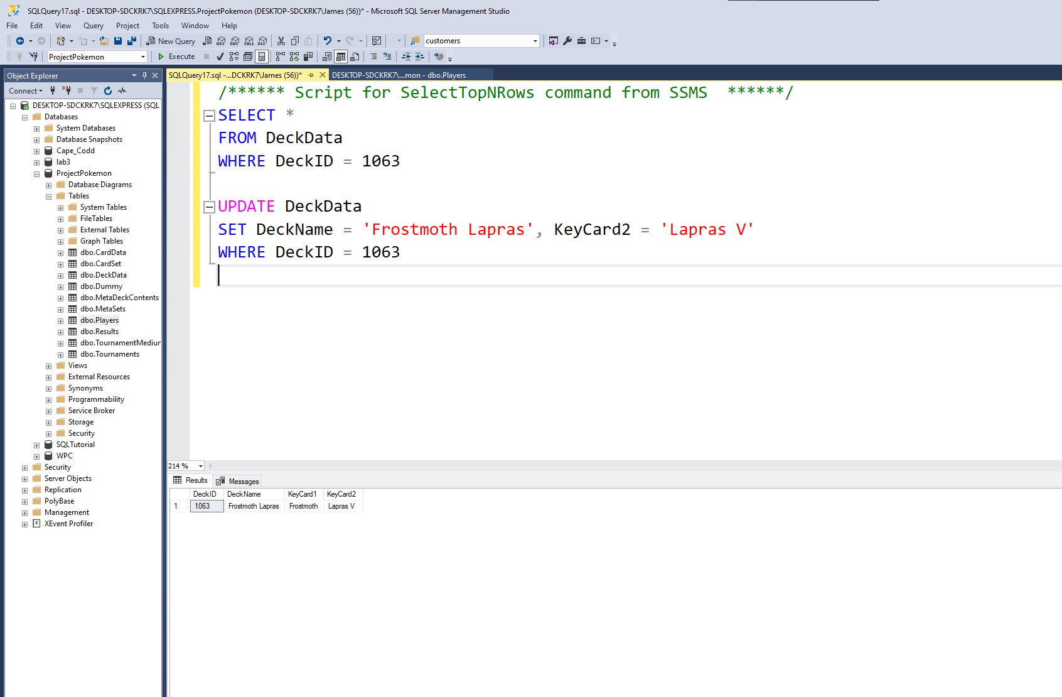

Wrong Deckname and key card

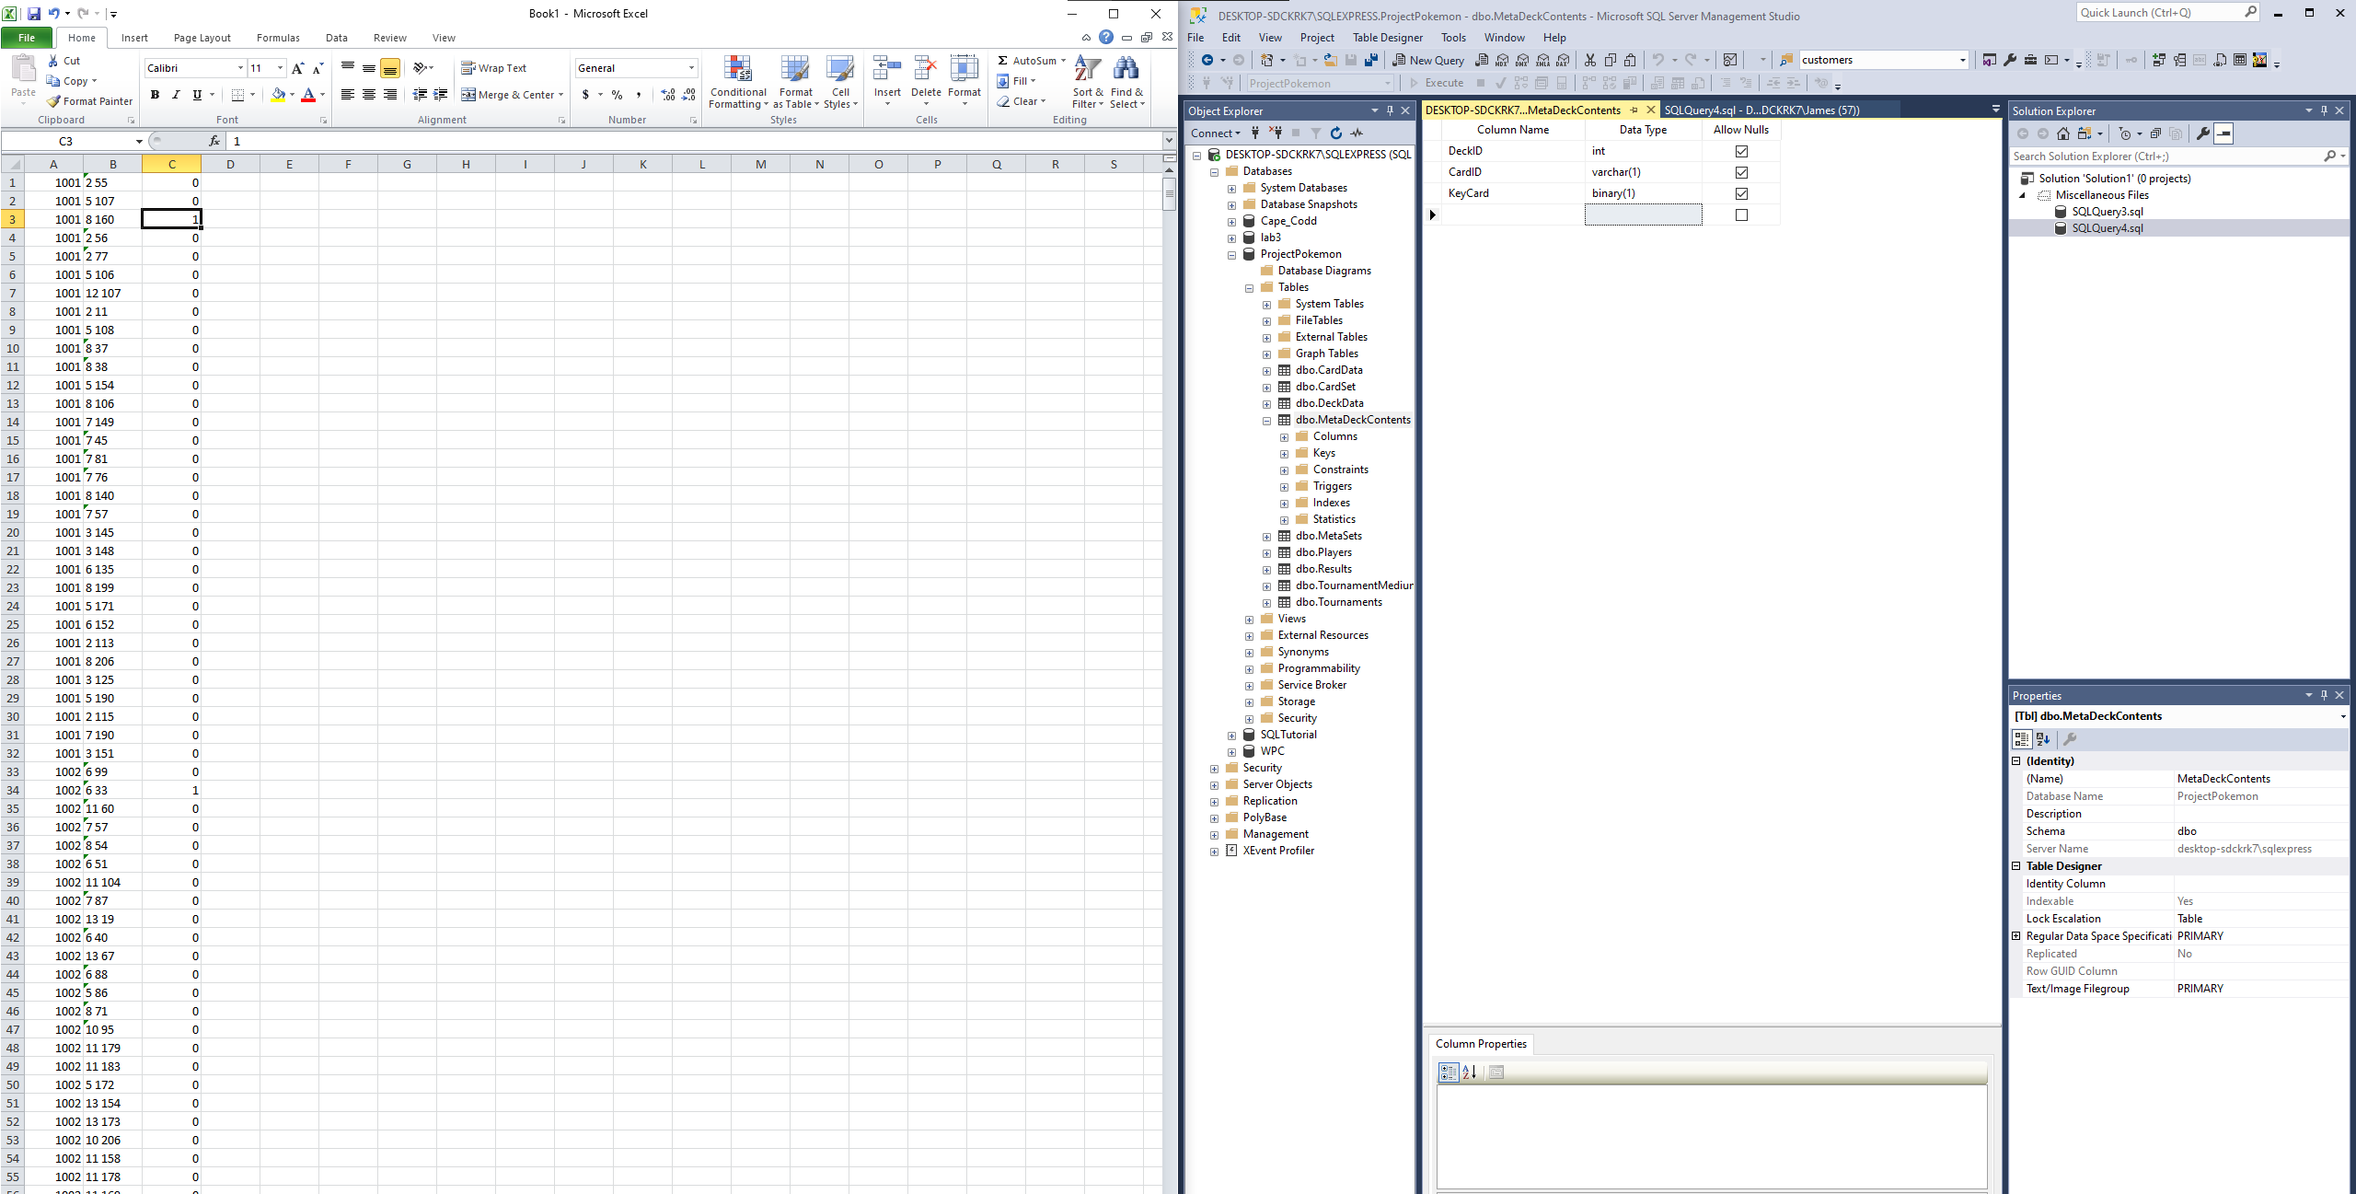

Adding binary datatype column for identification of a key card in a deck

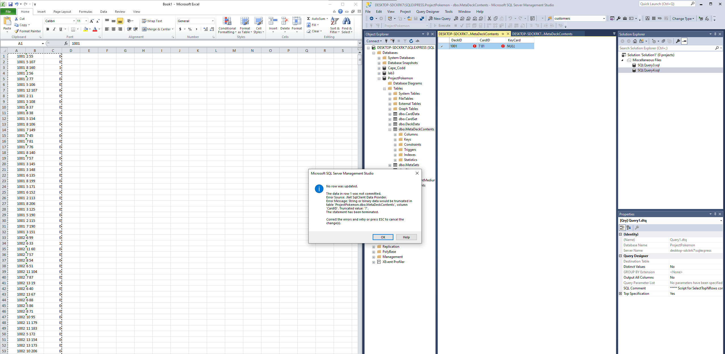

Bad idea to just cram in. TUrnication of id problem with varchar

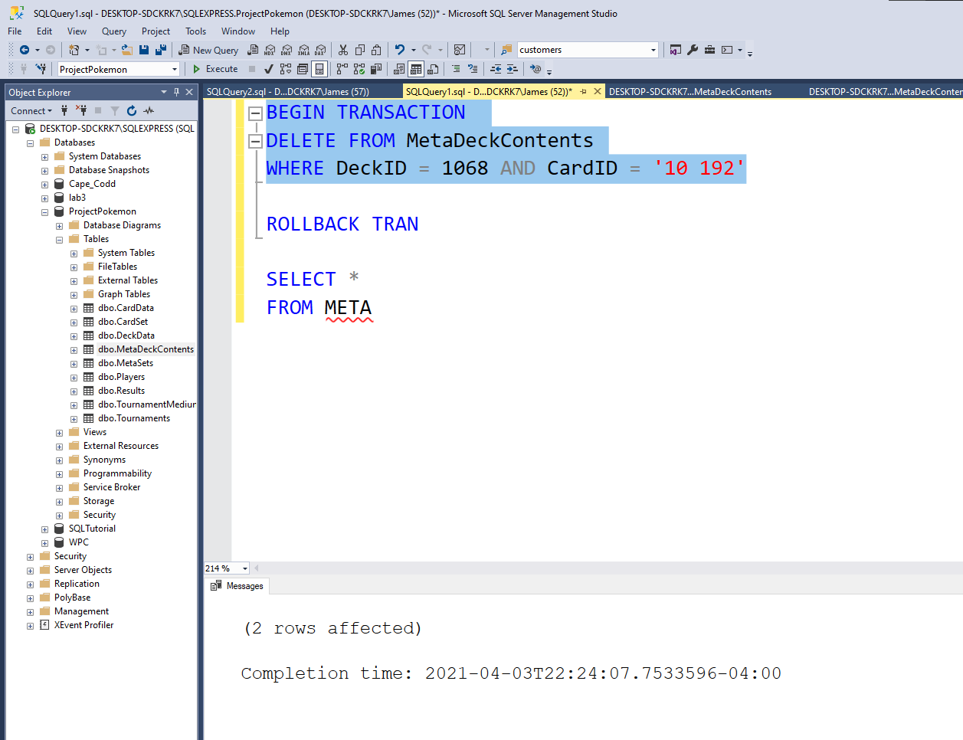

Found read only insert of data

Strange, should only be 1 card from removal but 2 were found

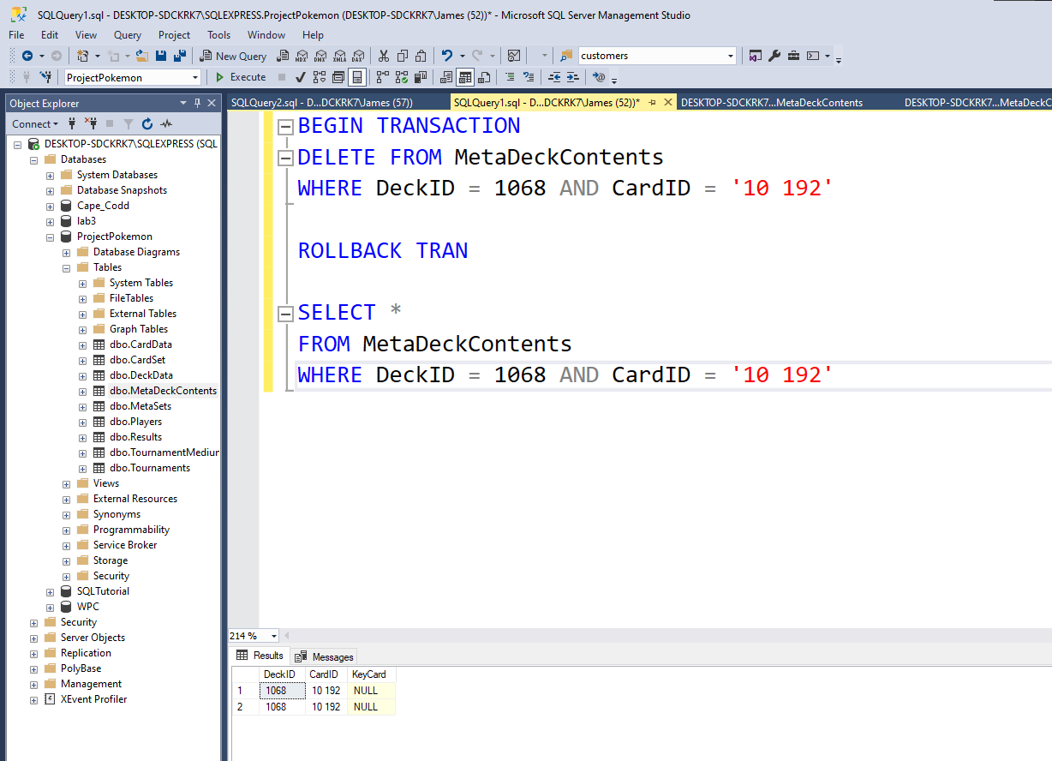

Removed both and readded

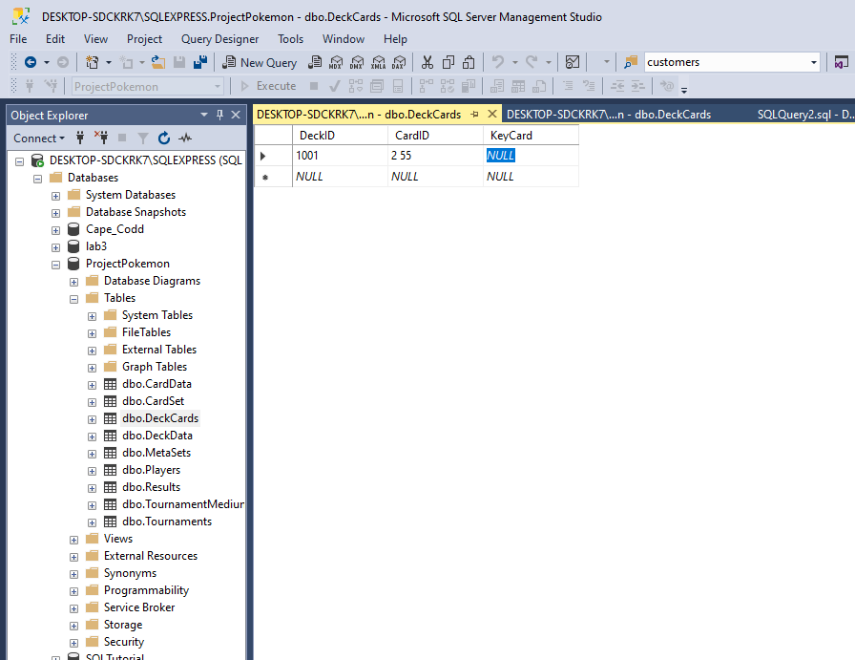

Problem binary coming up null

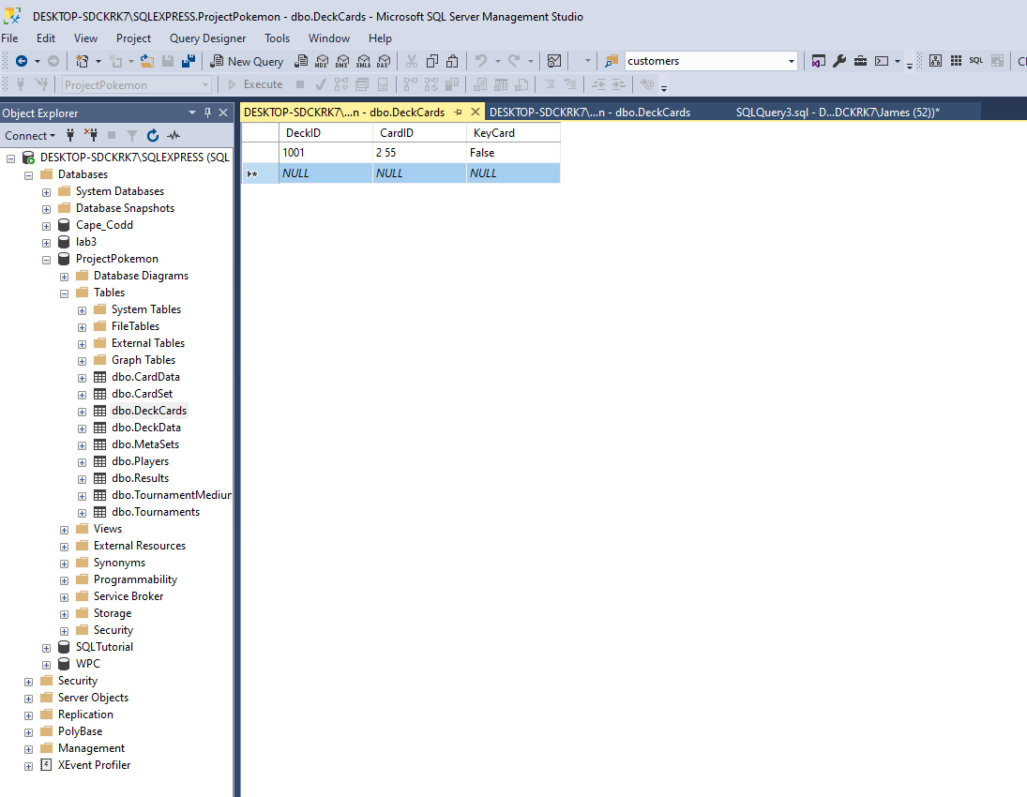

Instead use the bit datatype which can be 1, 0, null = T/F

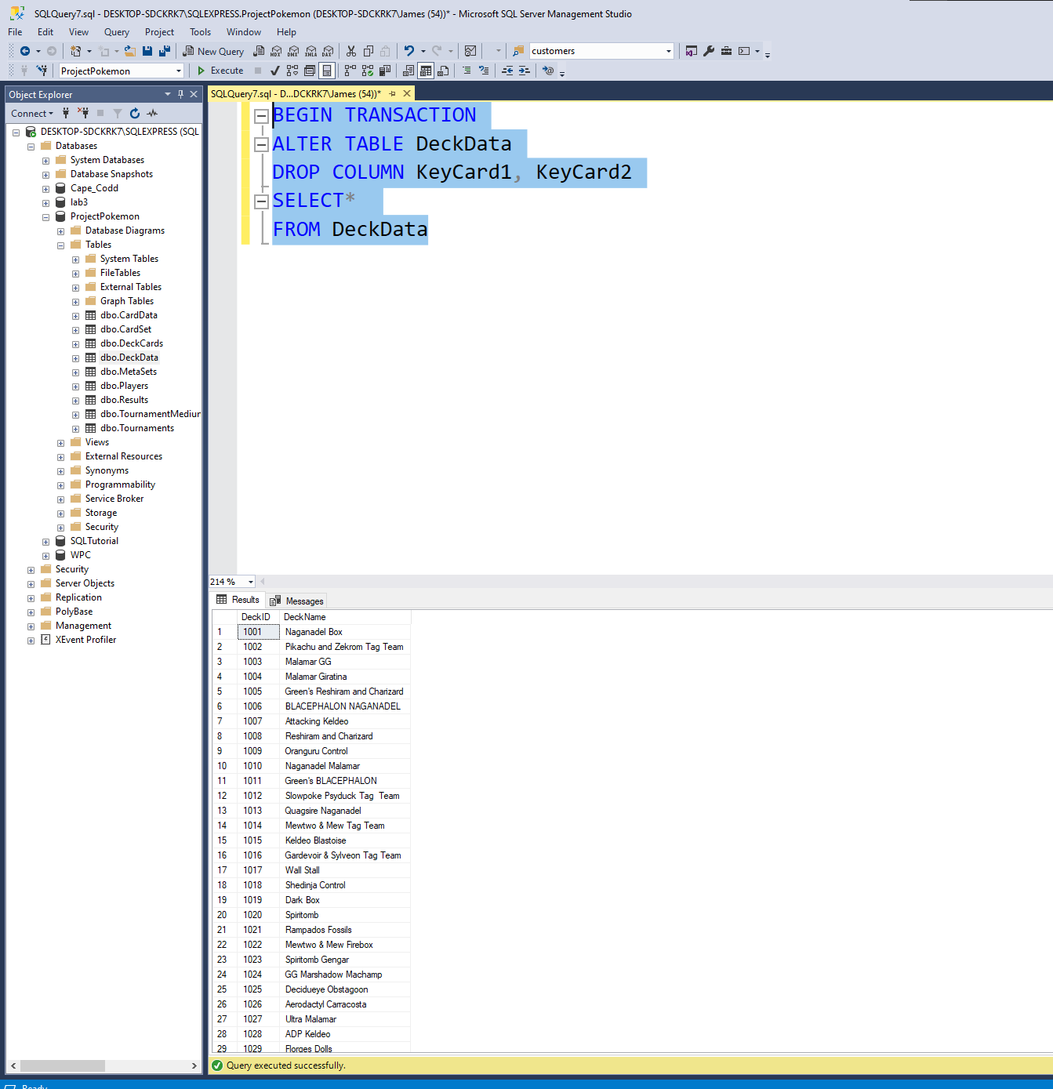

Because key cards were now stored in the DeckCard table we removed the repeted data from deck data.

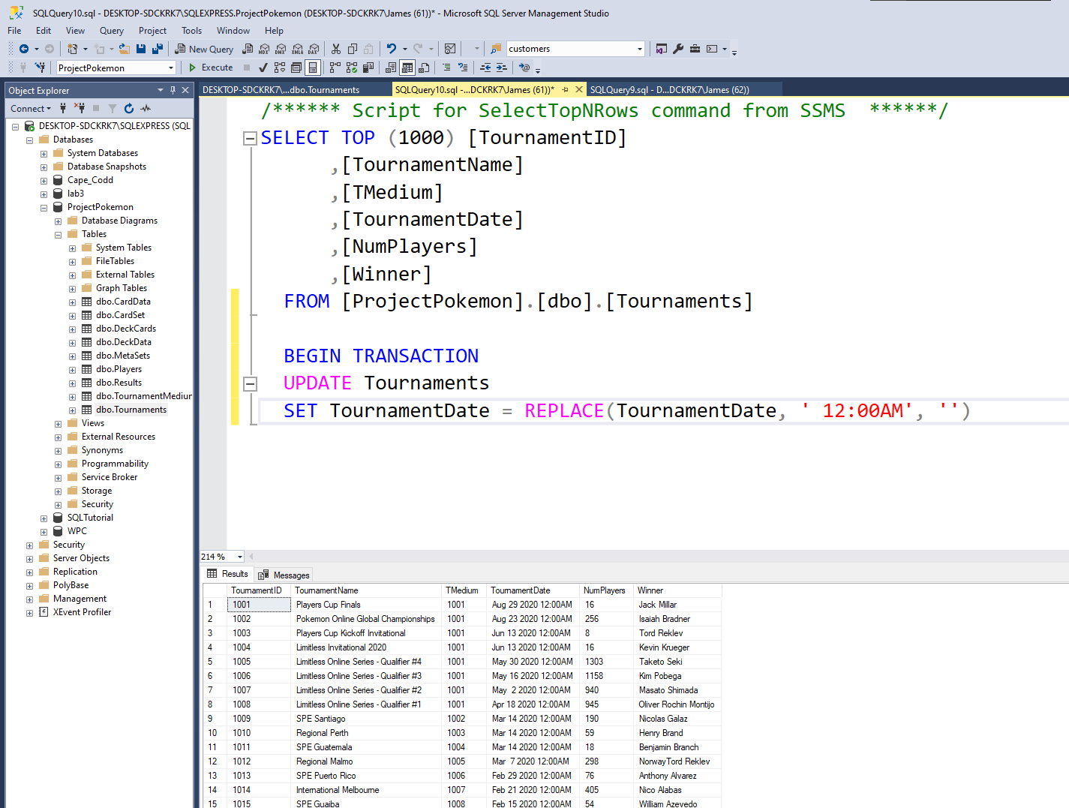

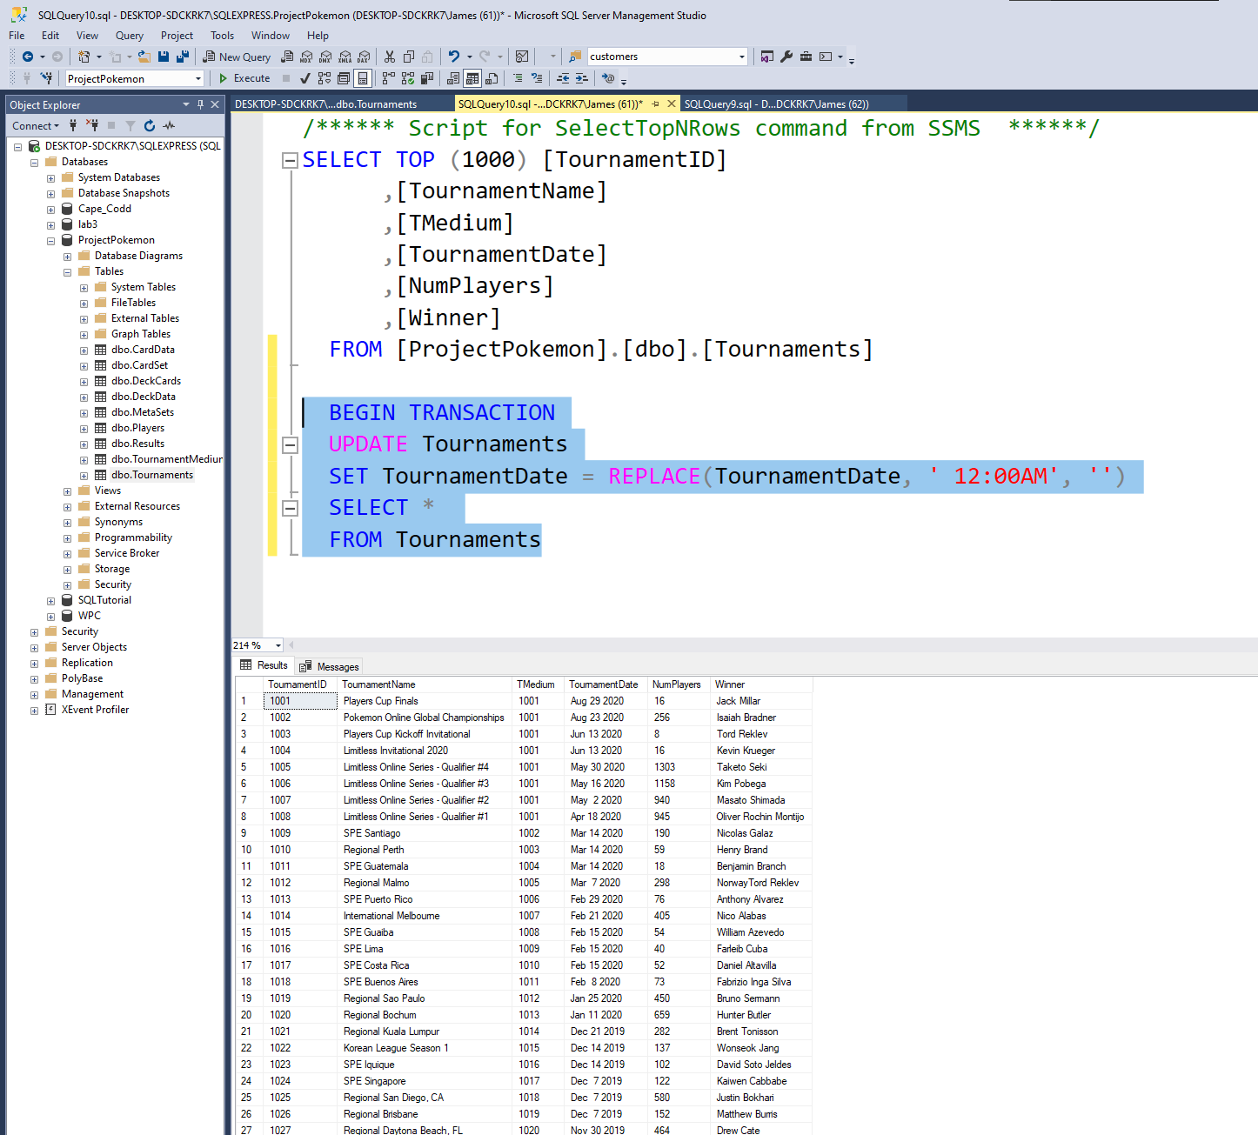

Removing unneeded time data from extracted data

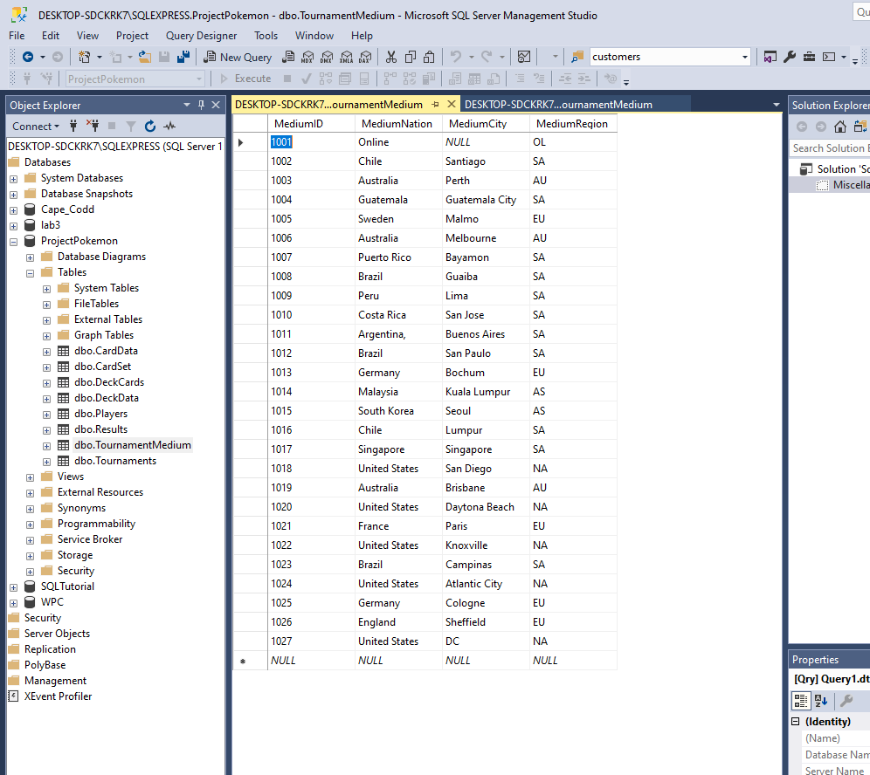

I thought it would be fun to see how regions play as well.

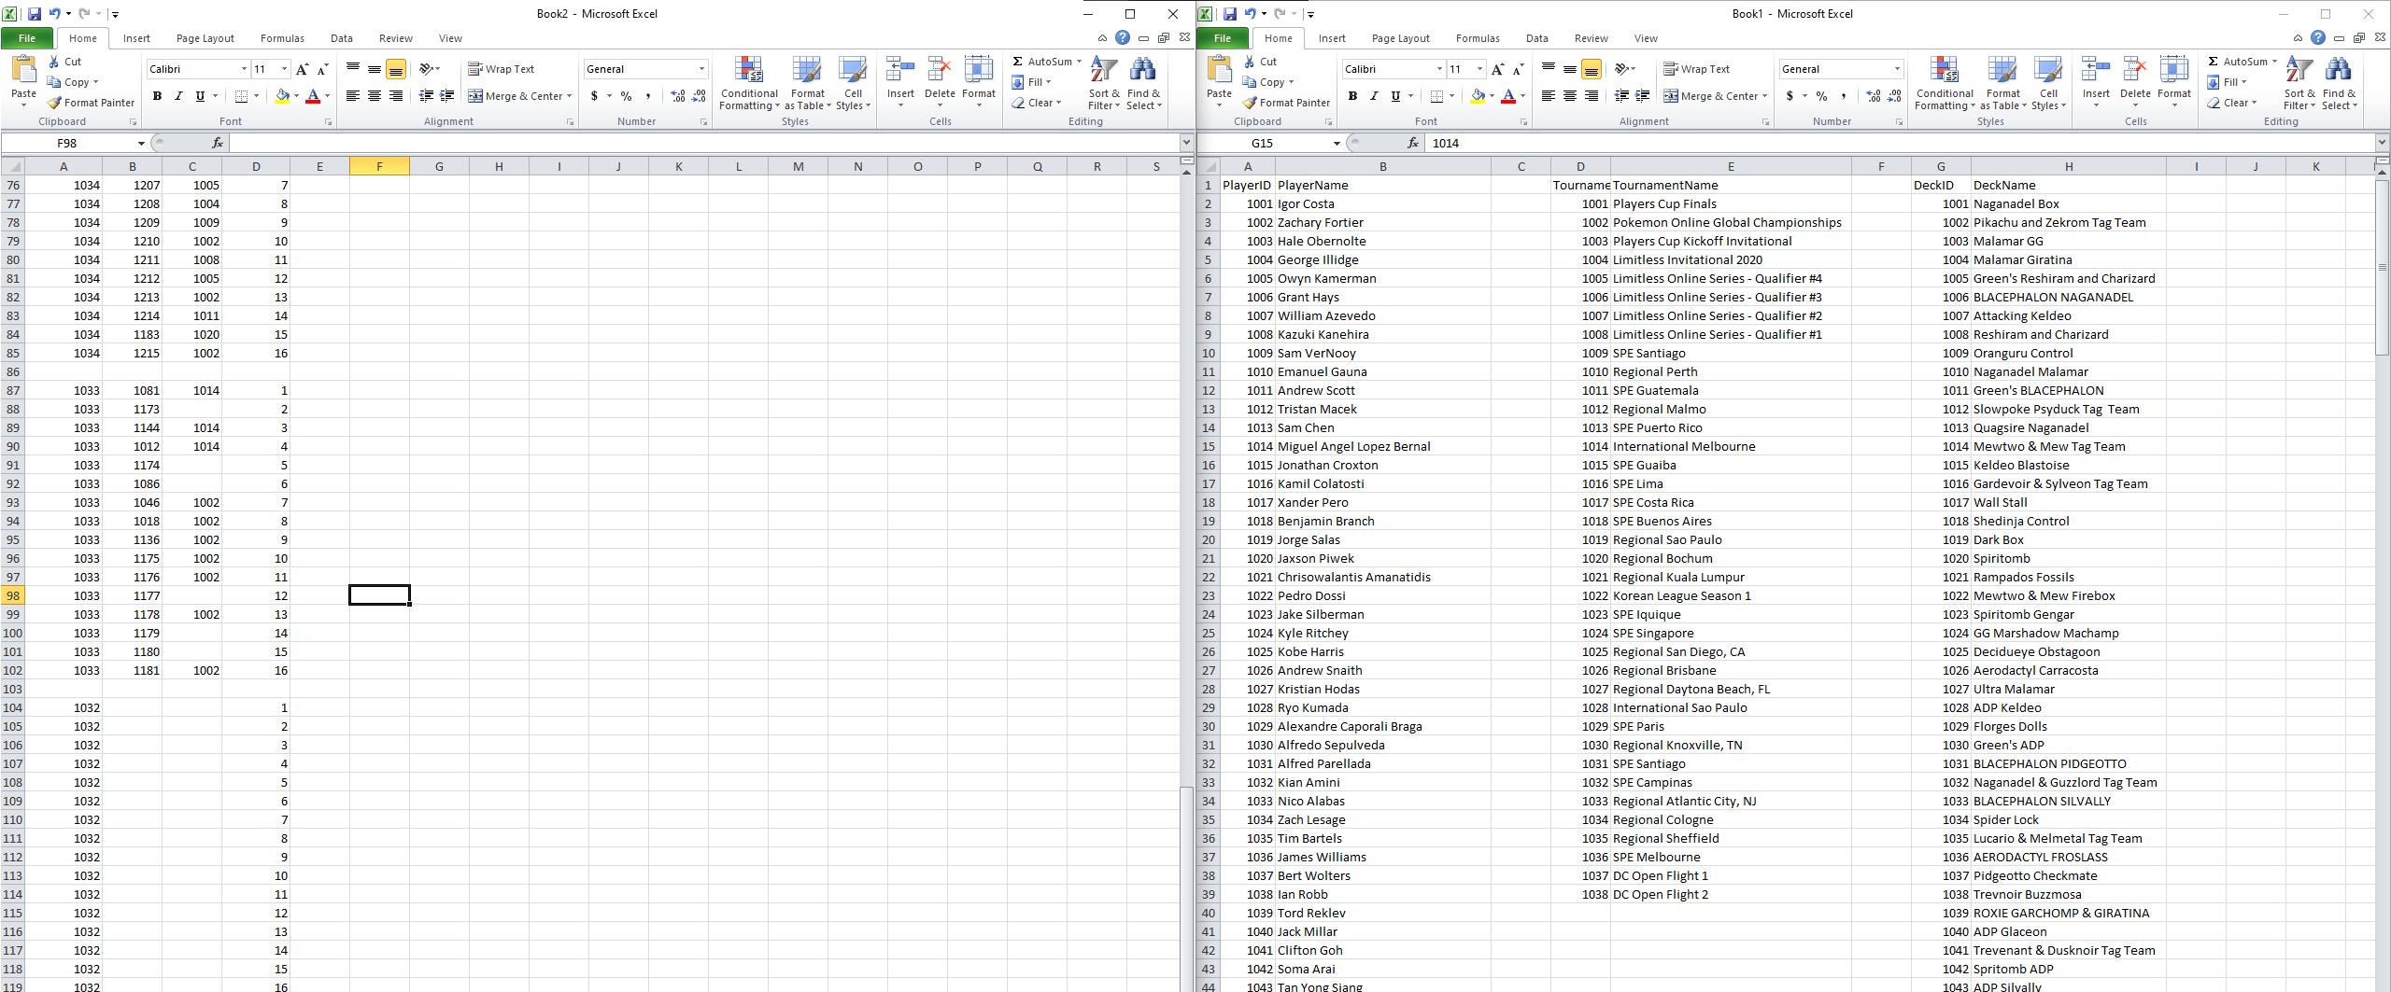

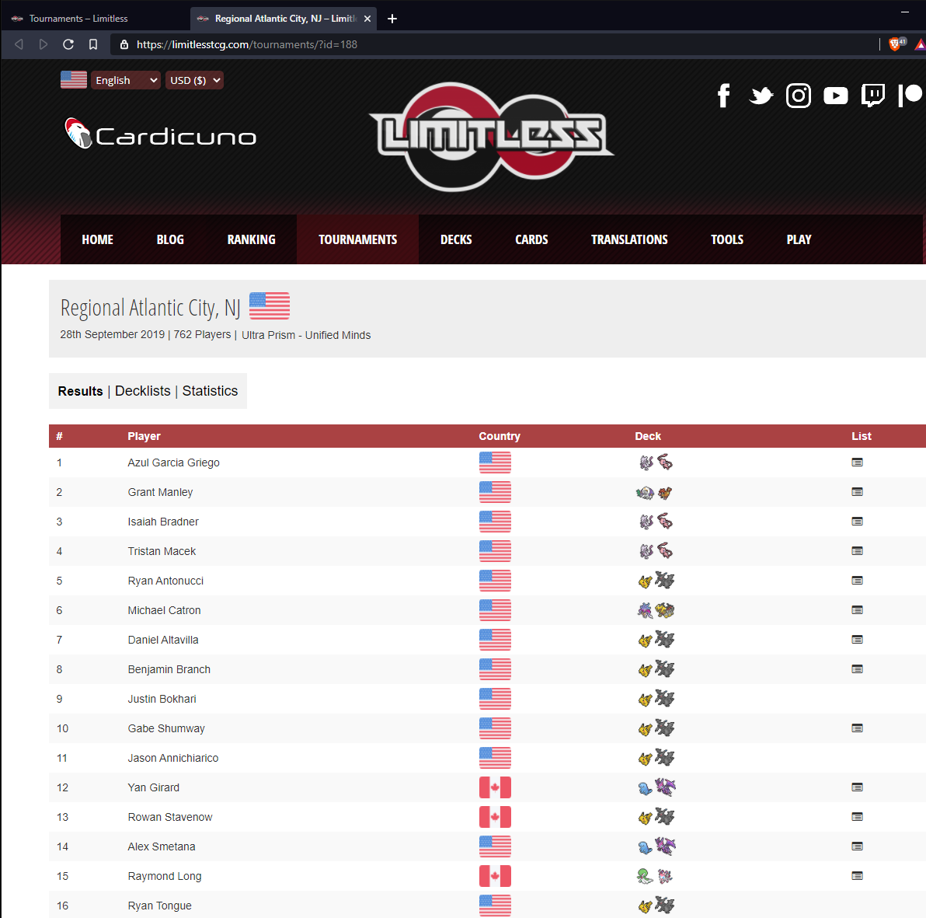

Creating tournament results by hand

Nice to have missing data points from deleting reused values, gave idea of how many player points people had and that I would see trends.

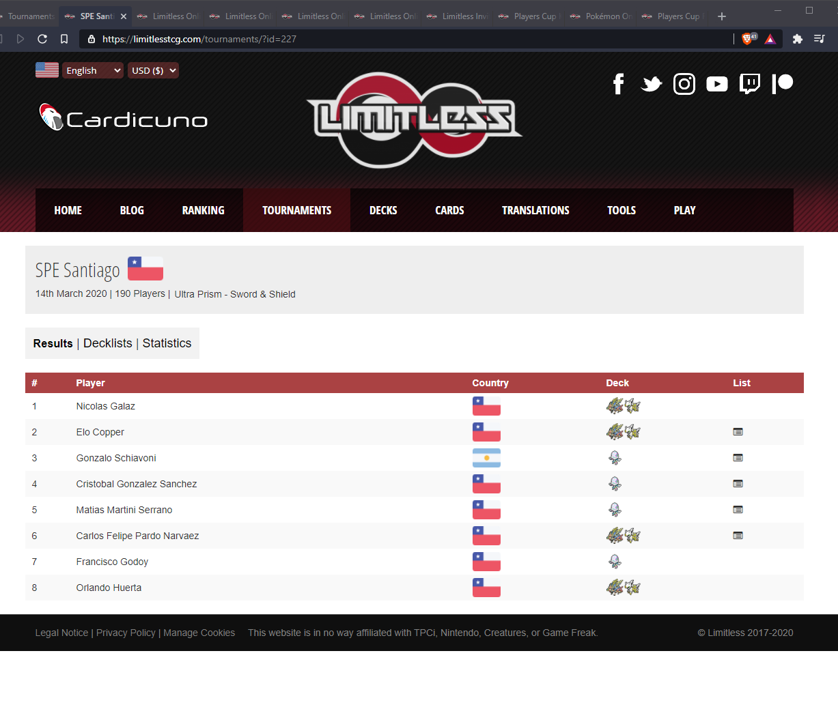

Example of meta devolution A<B<C<A = 1

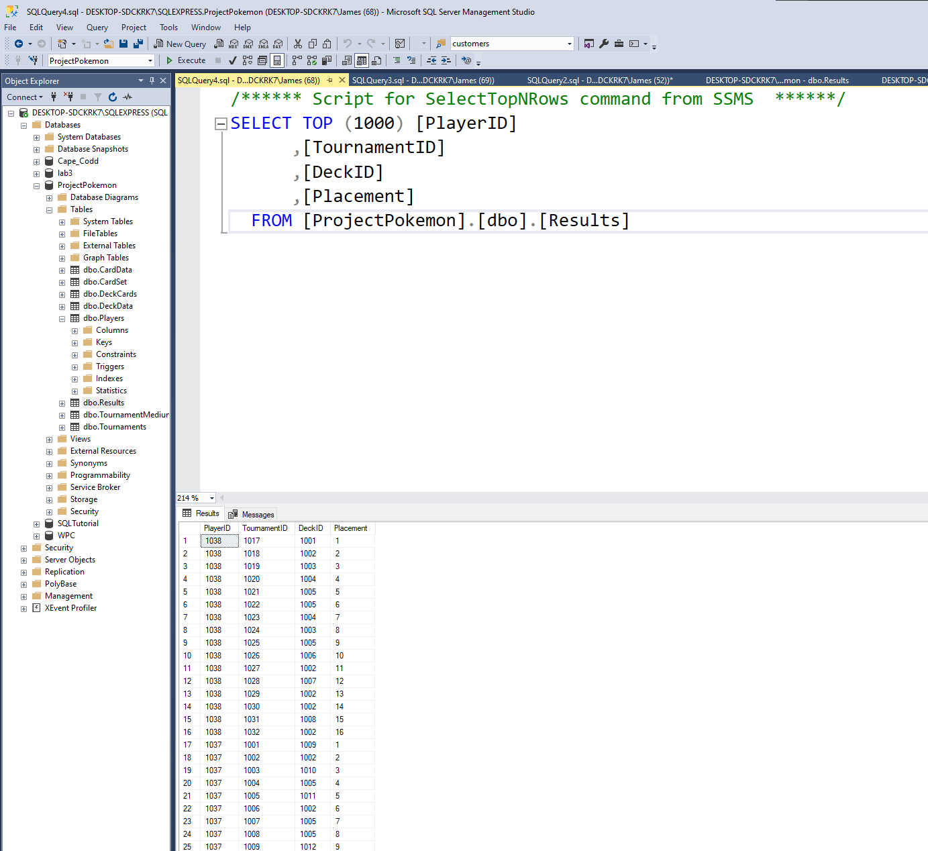

Data scare tournament ID and player ID names swapped

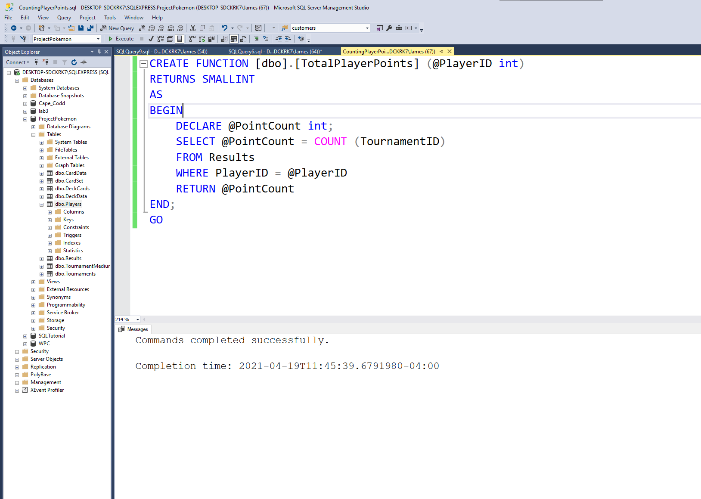

Creating function to count top 32 placements for each player

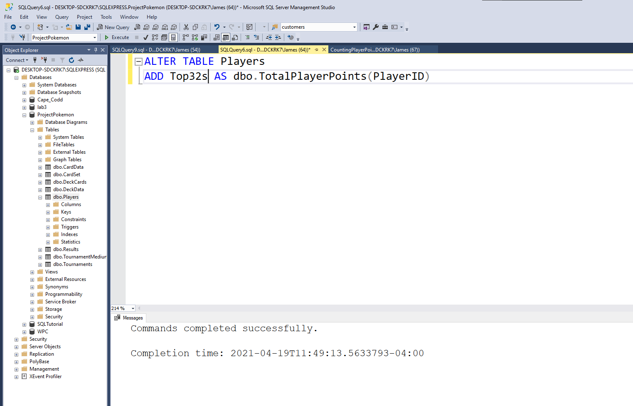

Adding it as a column for player info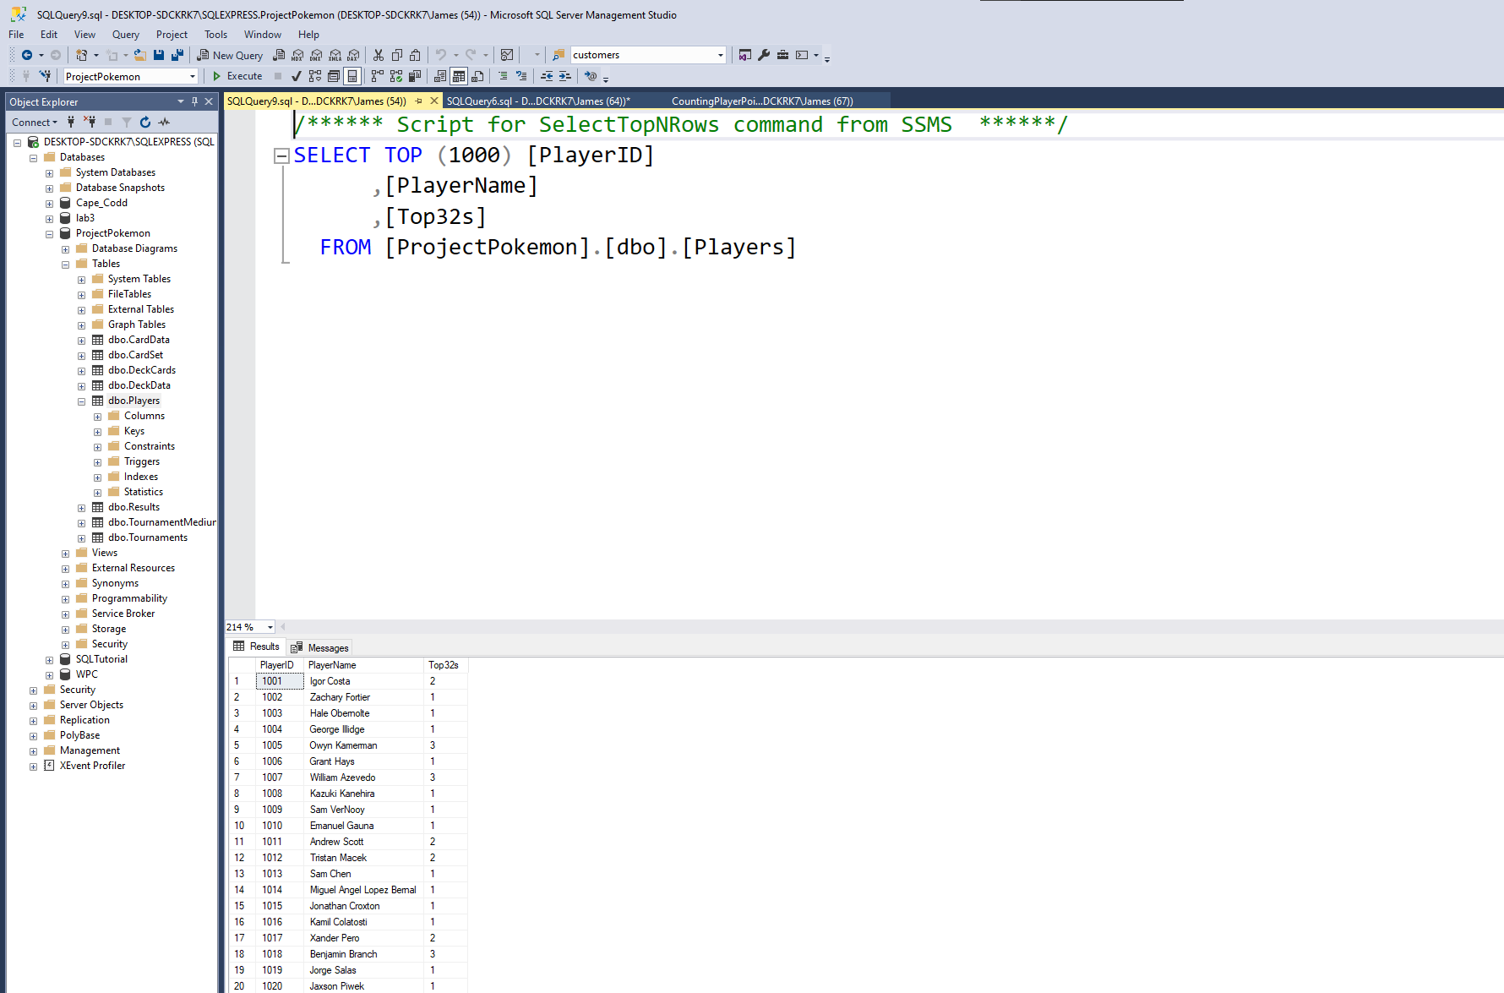

Results

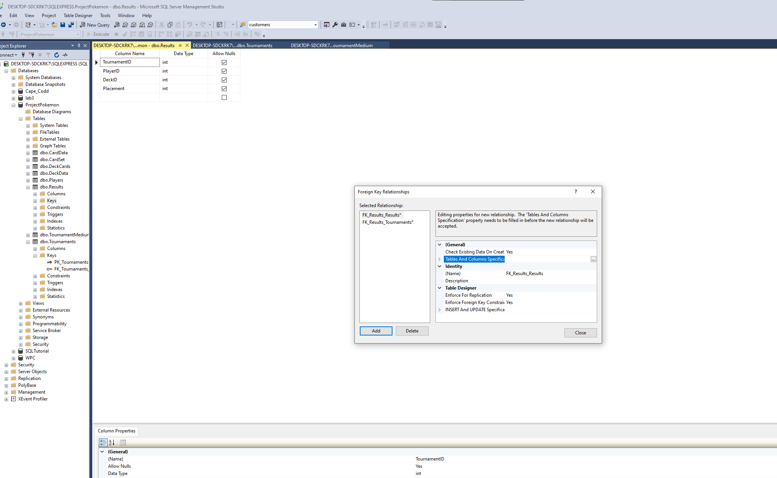

Adding forign keys to each table

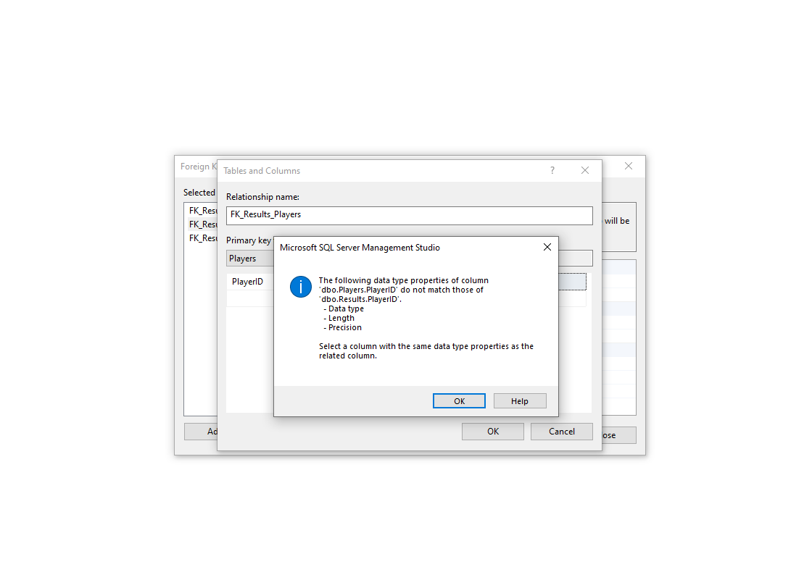

Missmatched data types I had player Id set to float, not sure where that reasoning came from

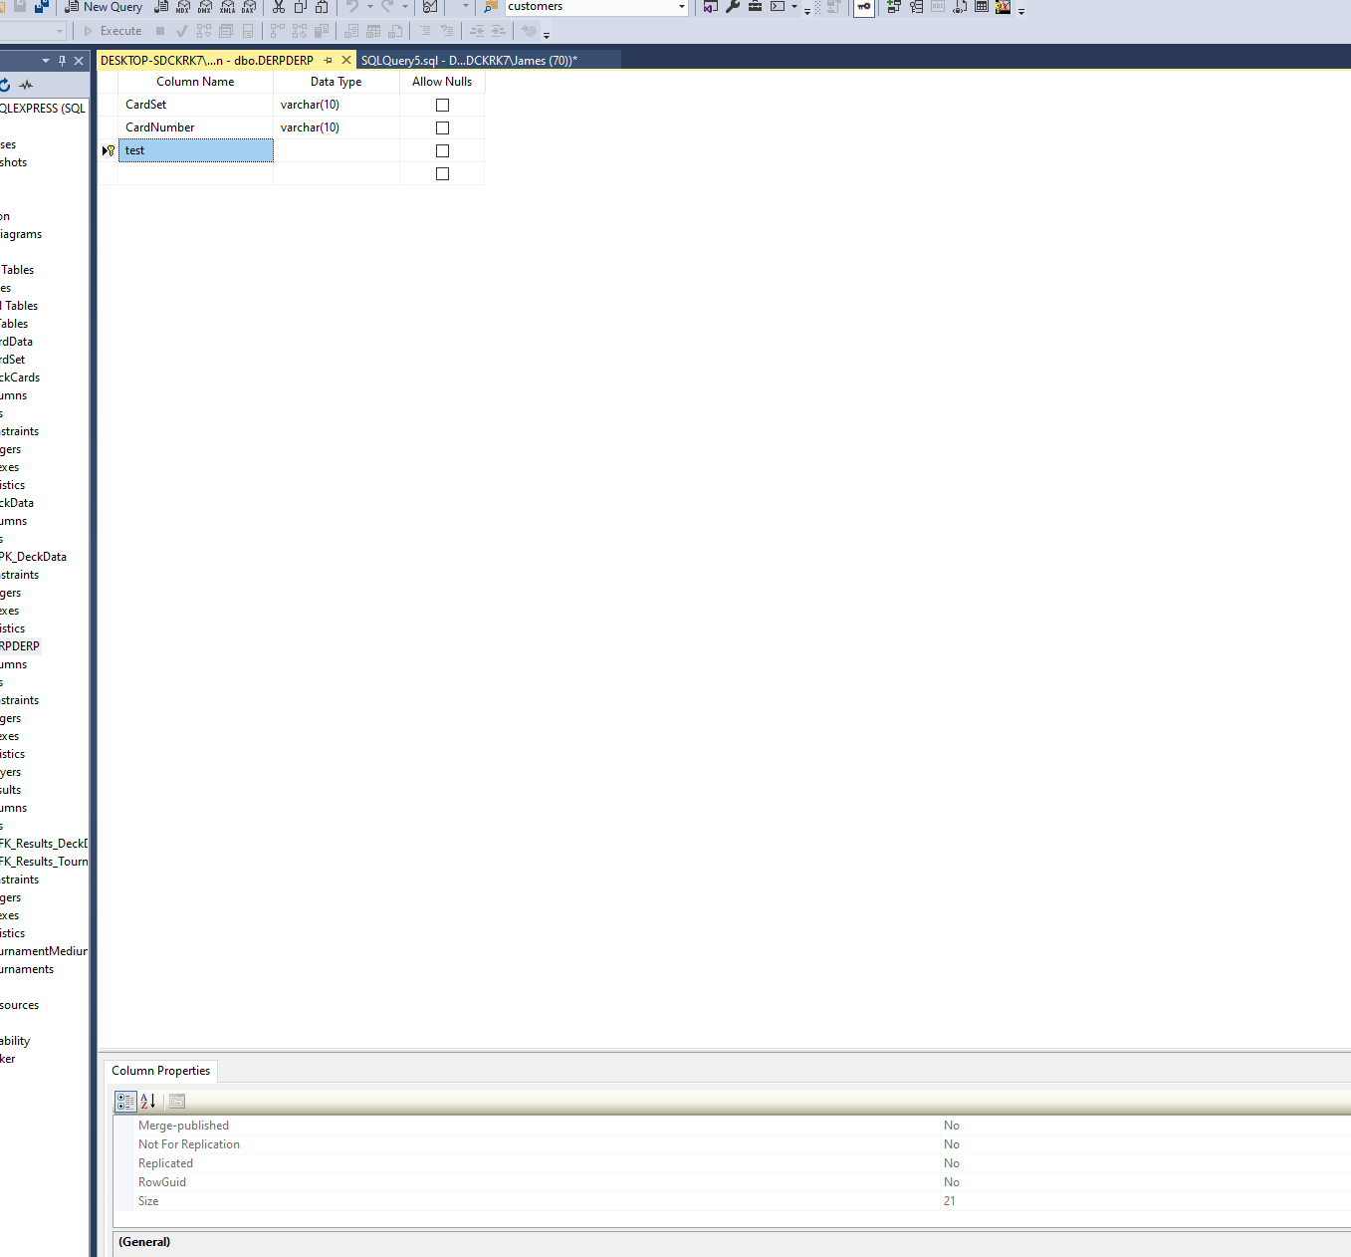

Computed column as forign key needed a lot of work using persisted and mainaining same size as other reciptient of key and allowing nulls for the composition of the computed column

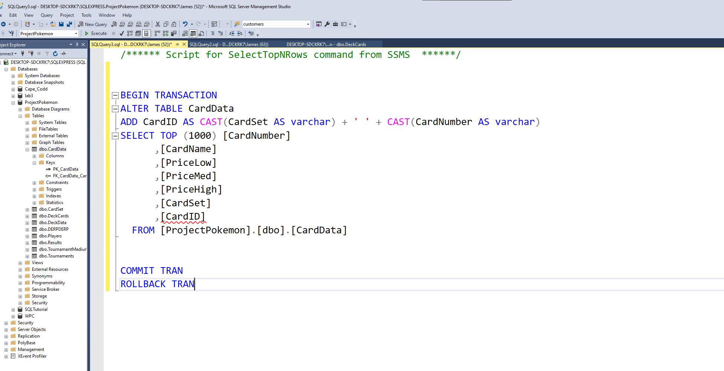

After removing repeted promo cards created card id for relationship to deckcards as forign key

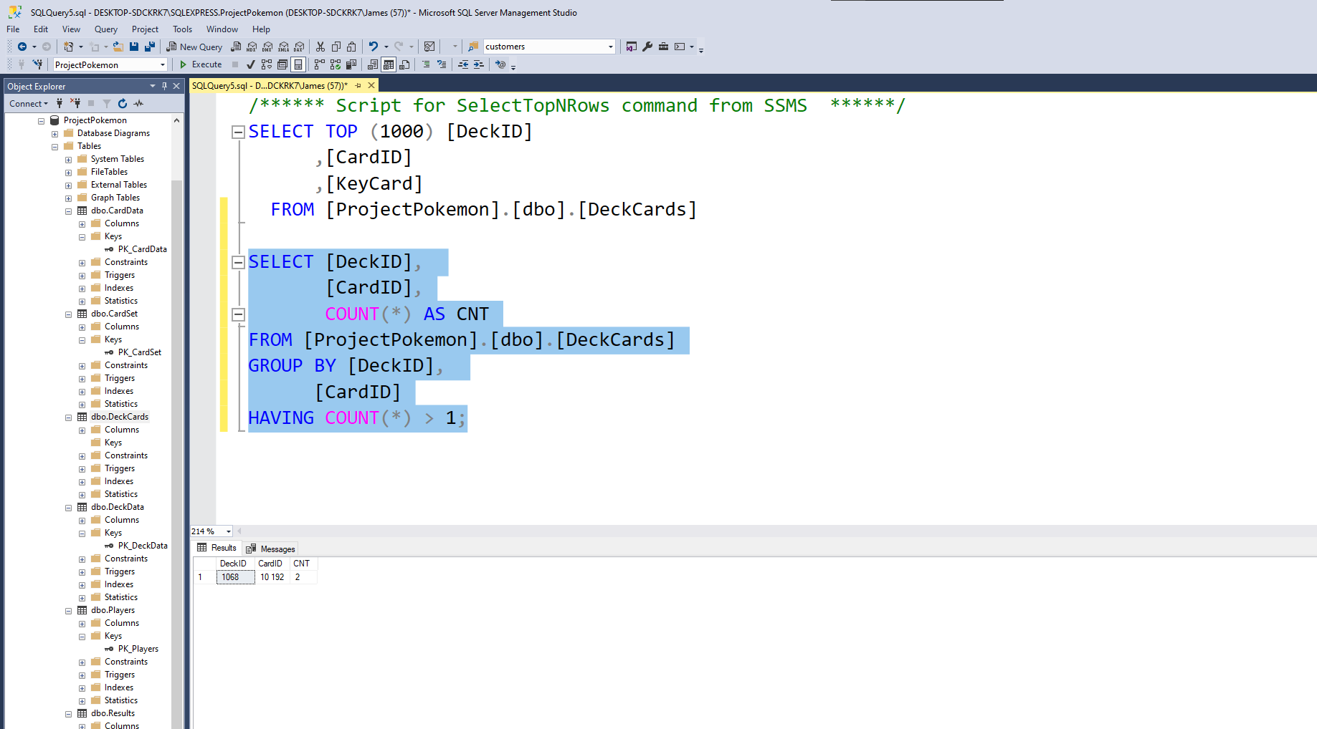

Repeted value needing removal

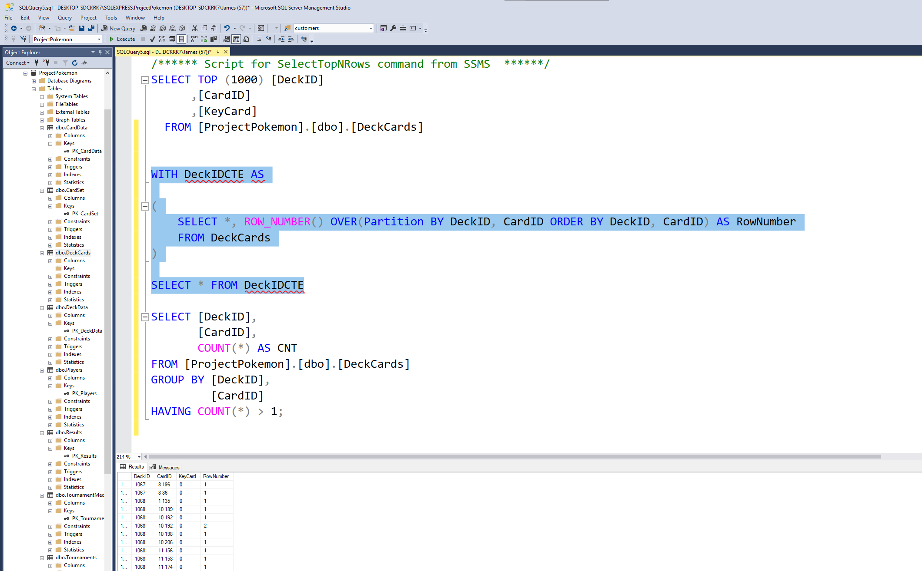

Parsing for repeted row

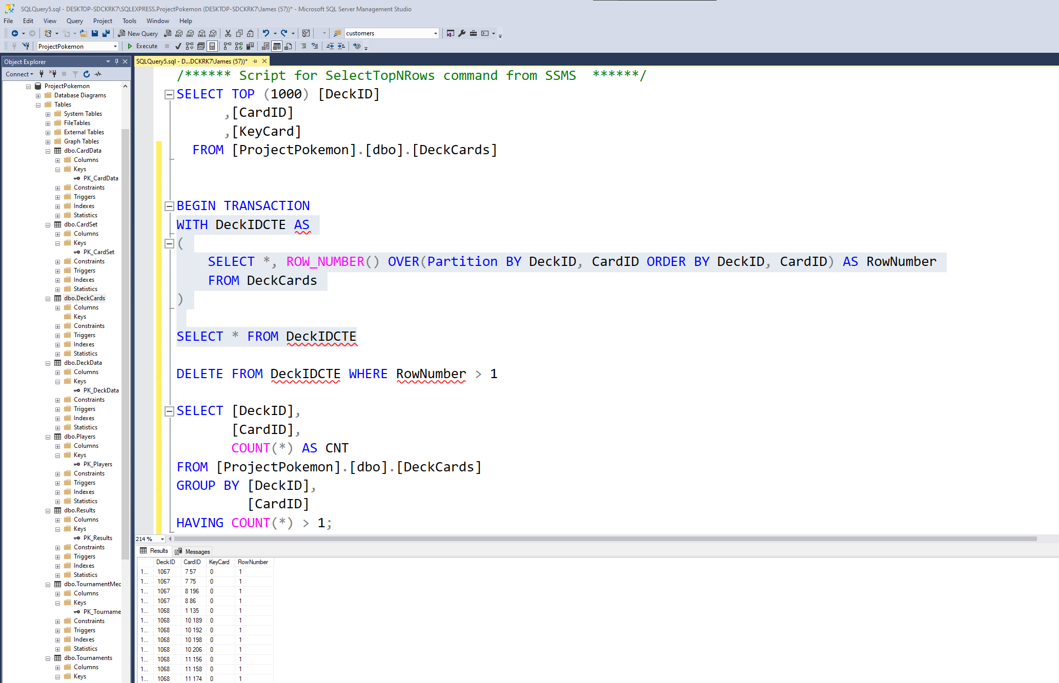

Deleting problem child

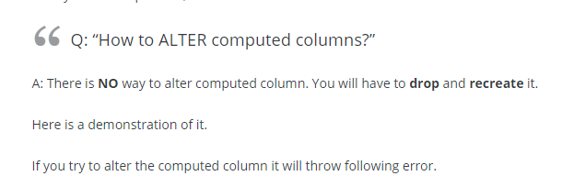

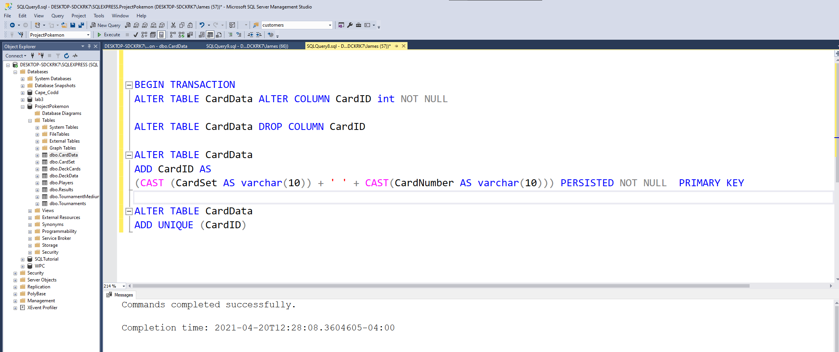

Getting the computed column to work as a primary key, contraints are harsh

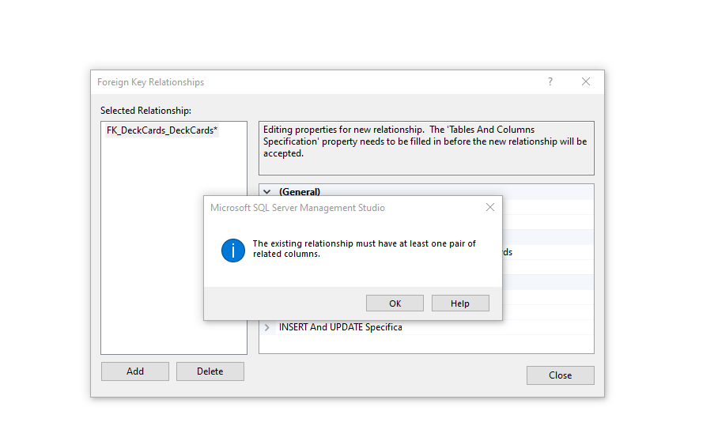

This error message needs a freaking cancel not help button

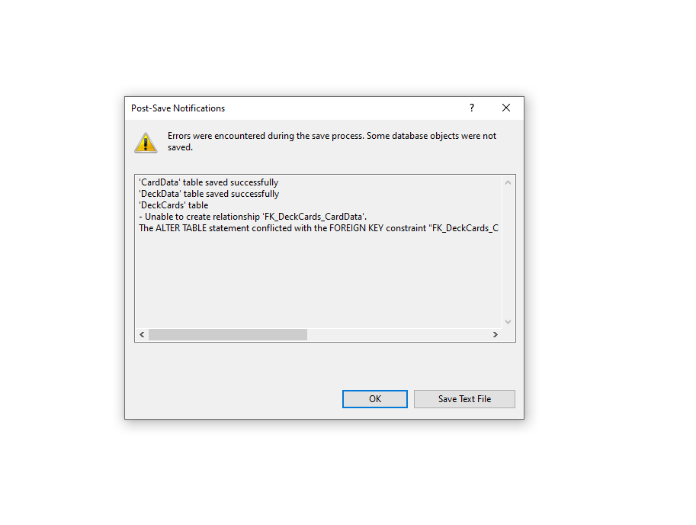

Failed referencial integrity to the cardID meaning didn’t find matches for forign key need to find failures

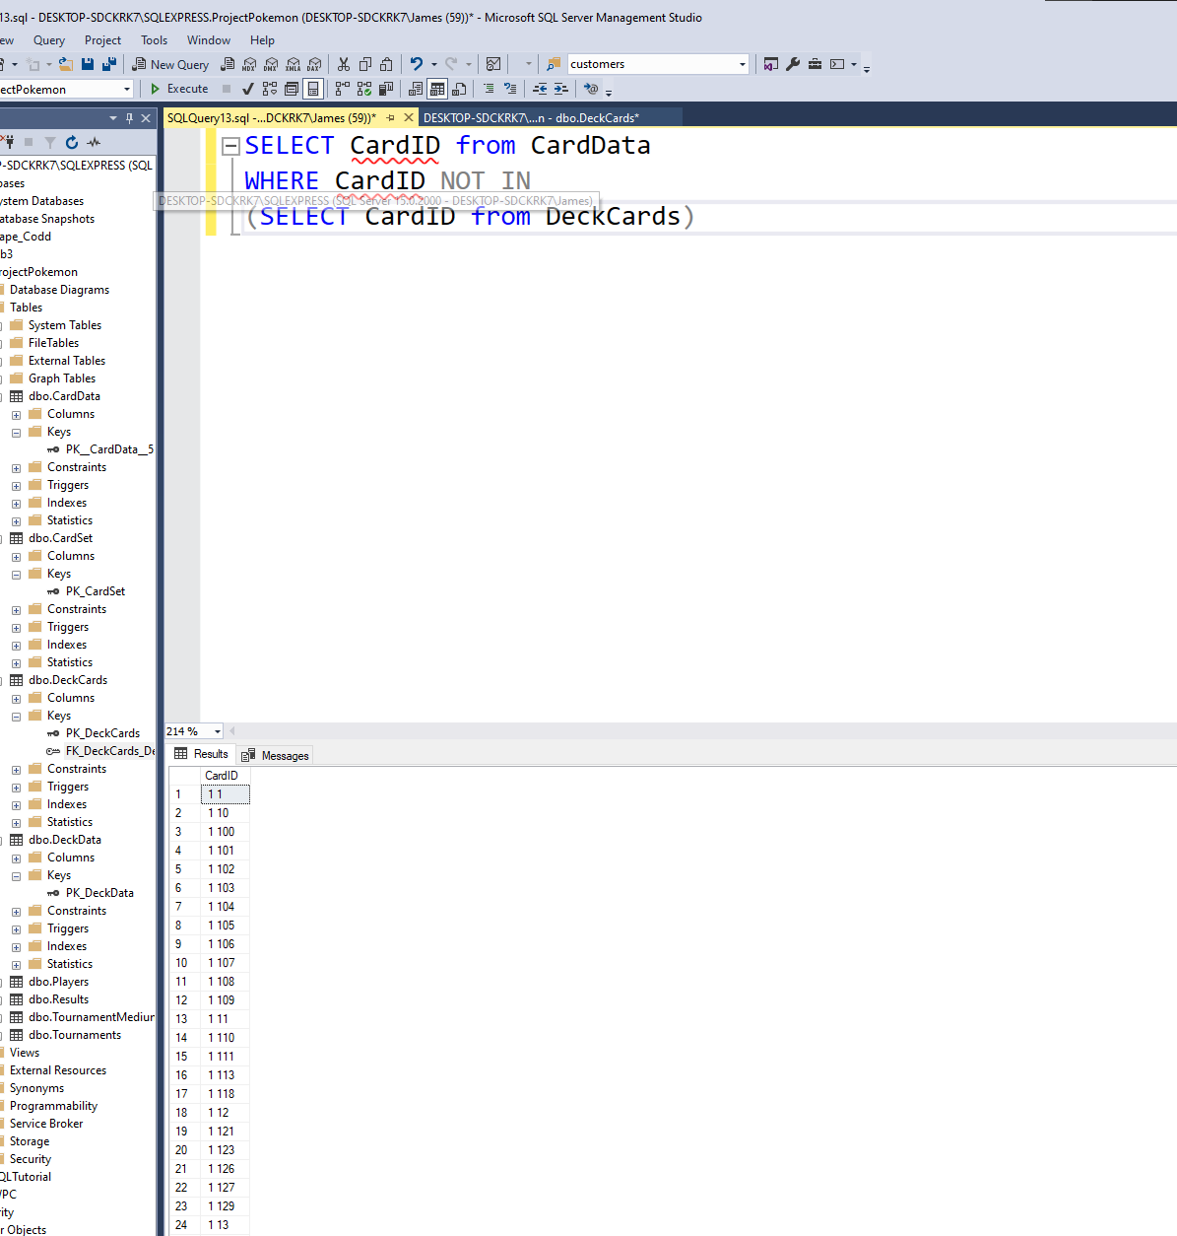

Views all as no matches

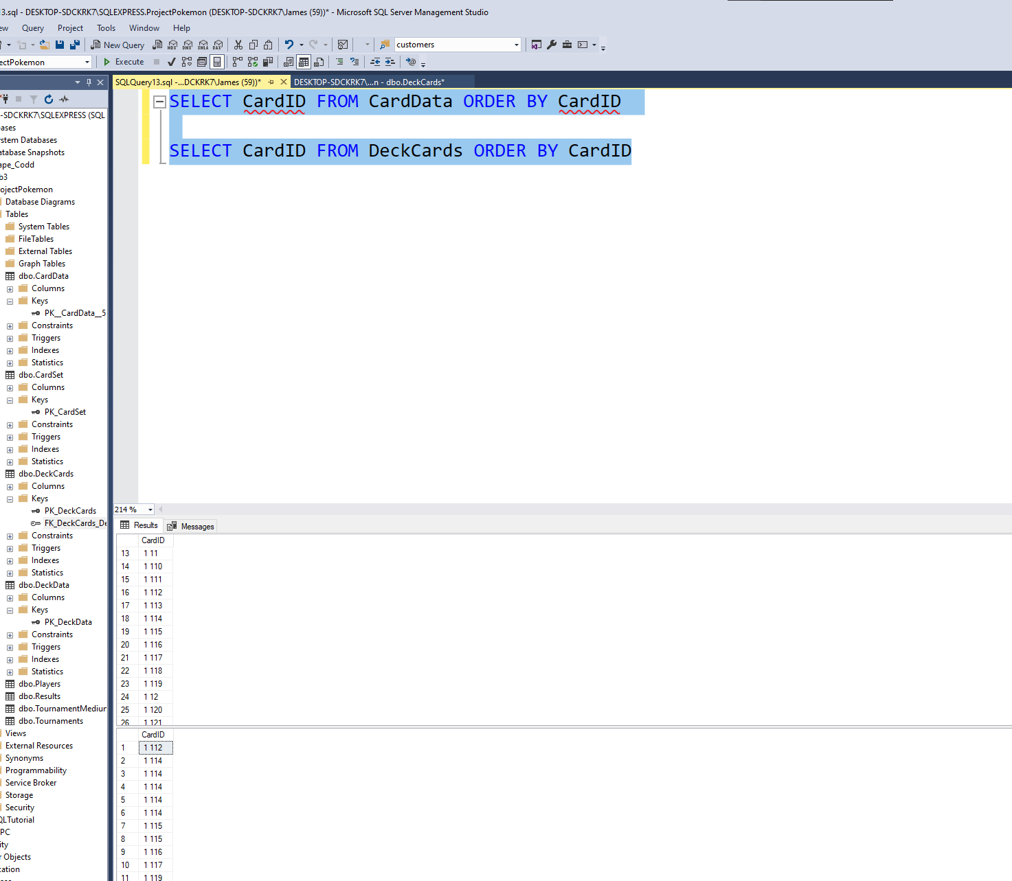

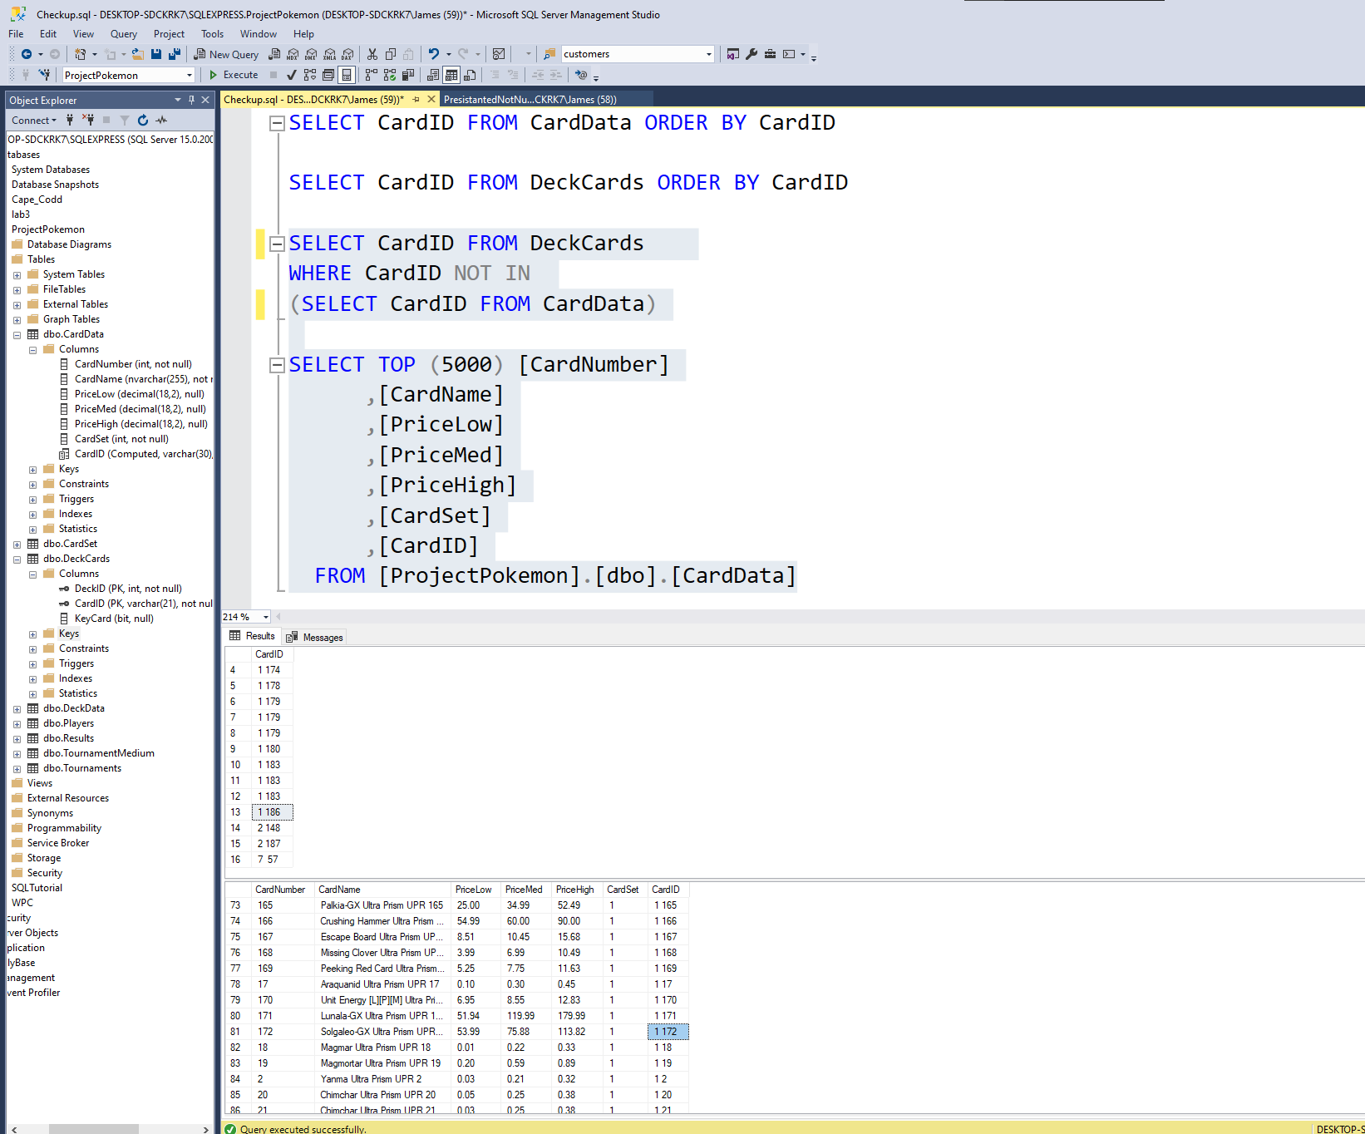

Missing data for forign key

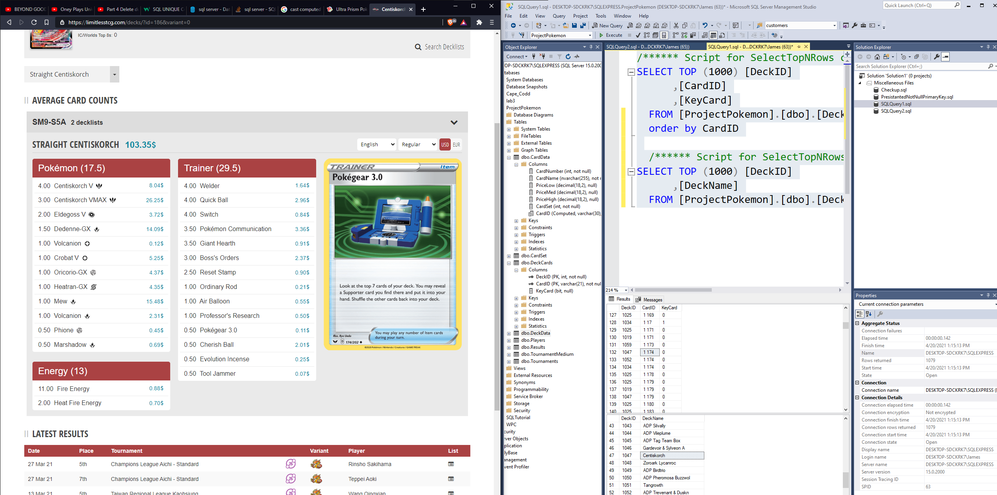

Example missing data, actually bad data as input 174 is not 174 but 1074, clearly all 1s are supposed to be 10s as the 1 set stops at a lower number than 174

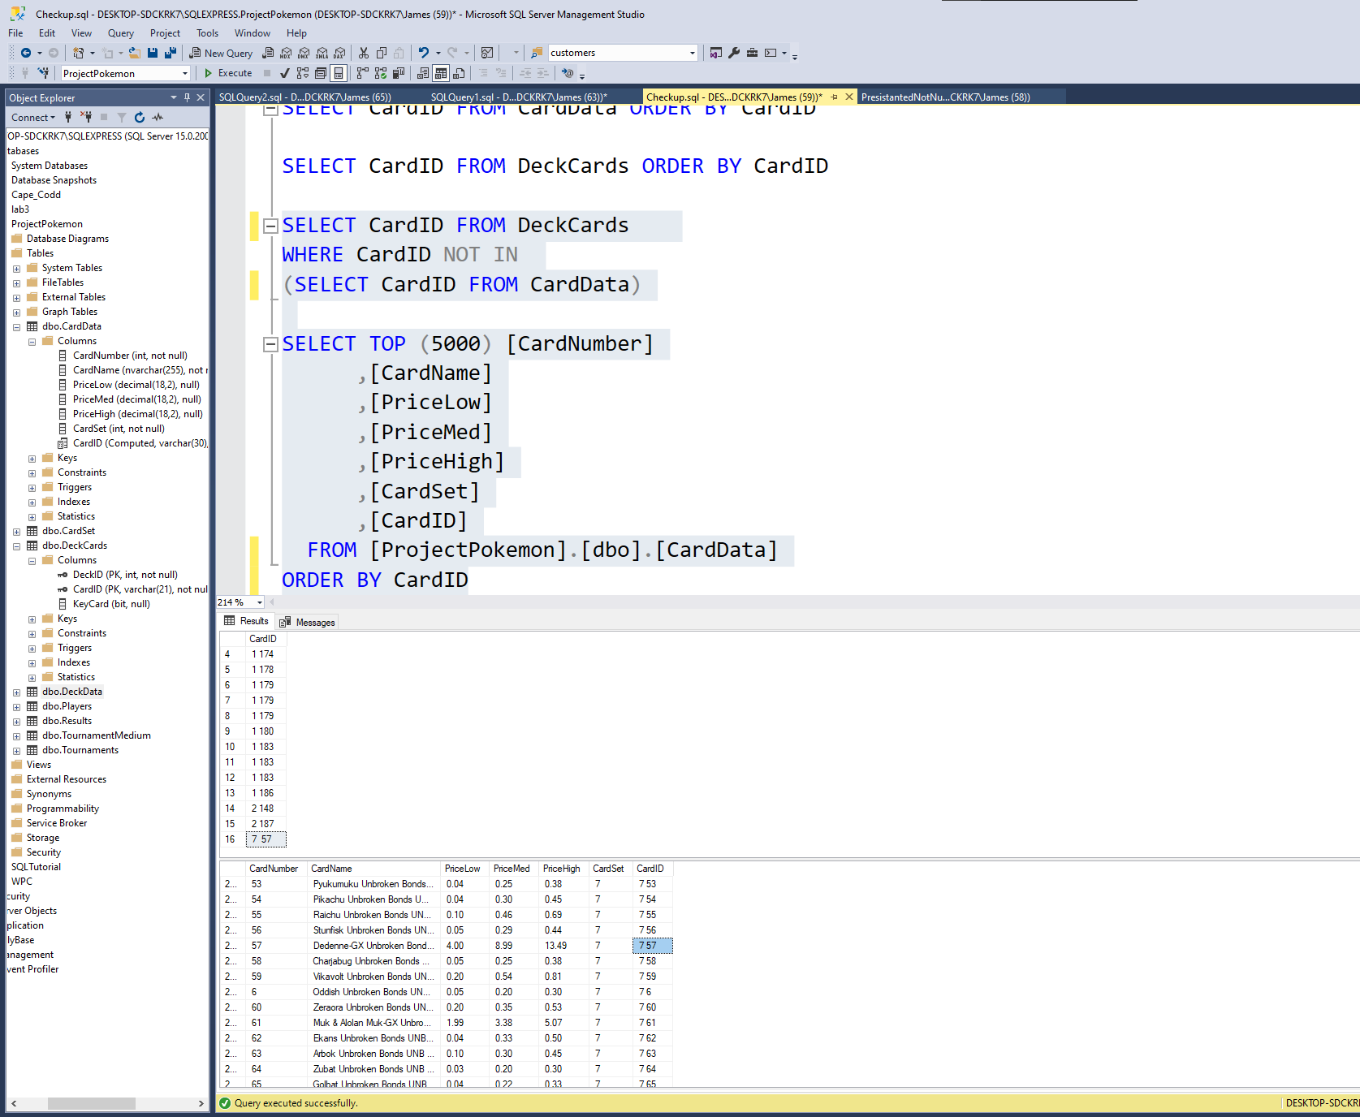

Clearly all of the 1 2 sets don’t exist, but why doesn’t 7 57 exist?

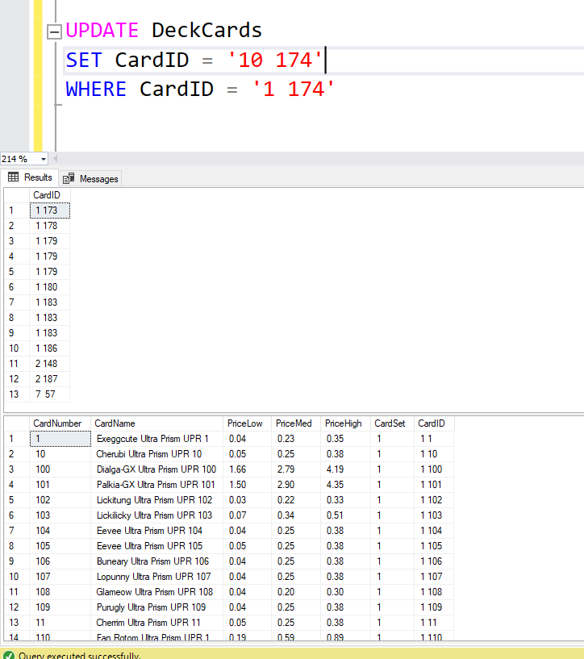

Getting rid of set 1 and 2 issues, to then work on set 7 card 57

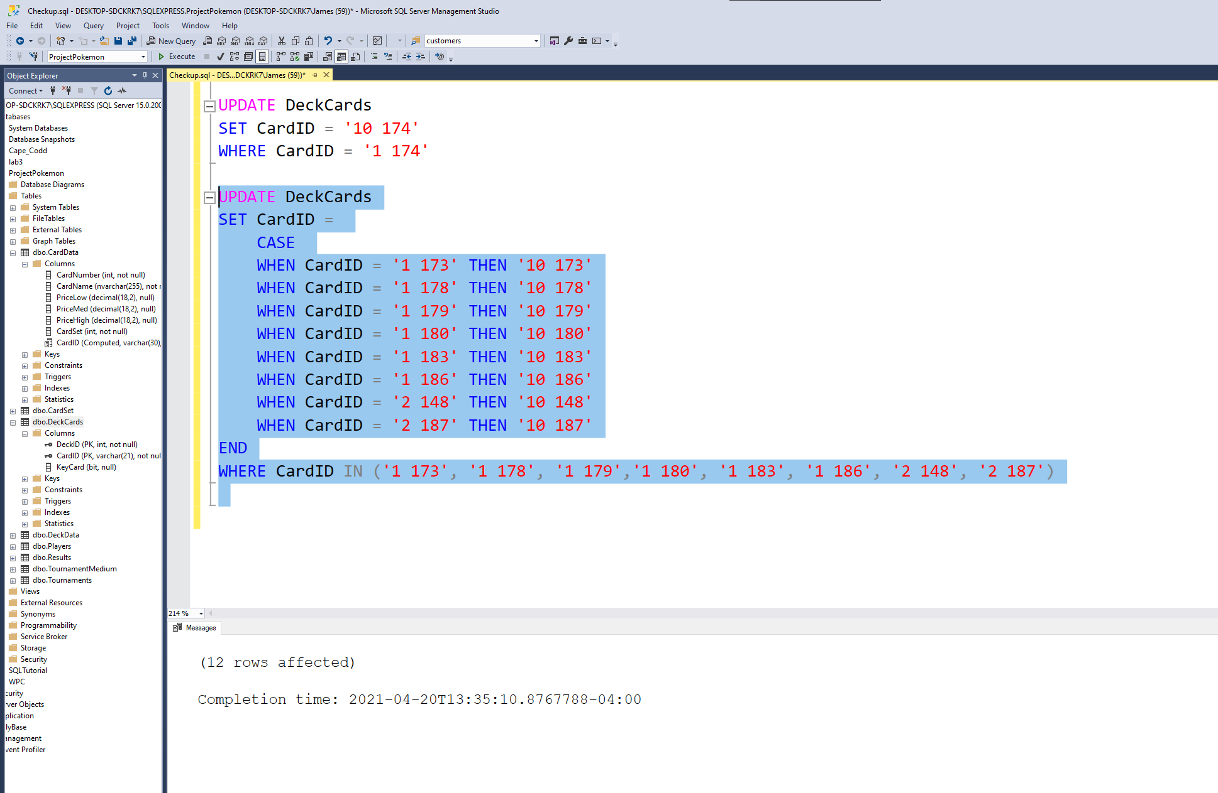

Updating miss info

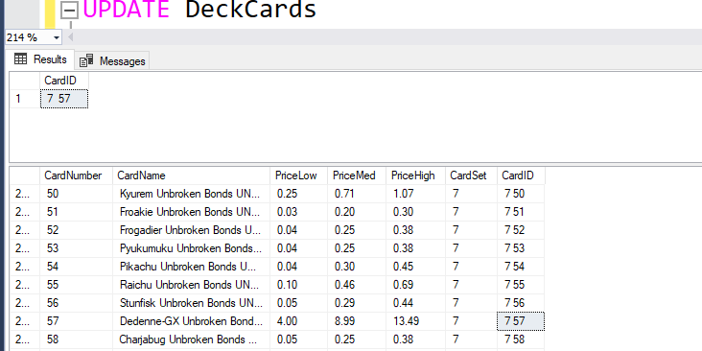

There are 2 spaces between 7 and 57 in the deck cards

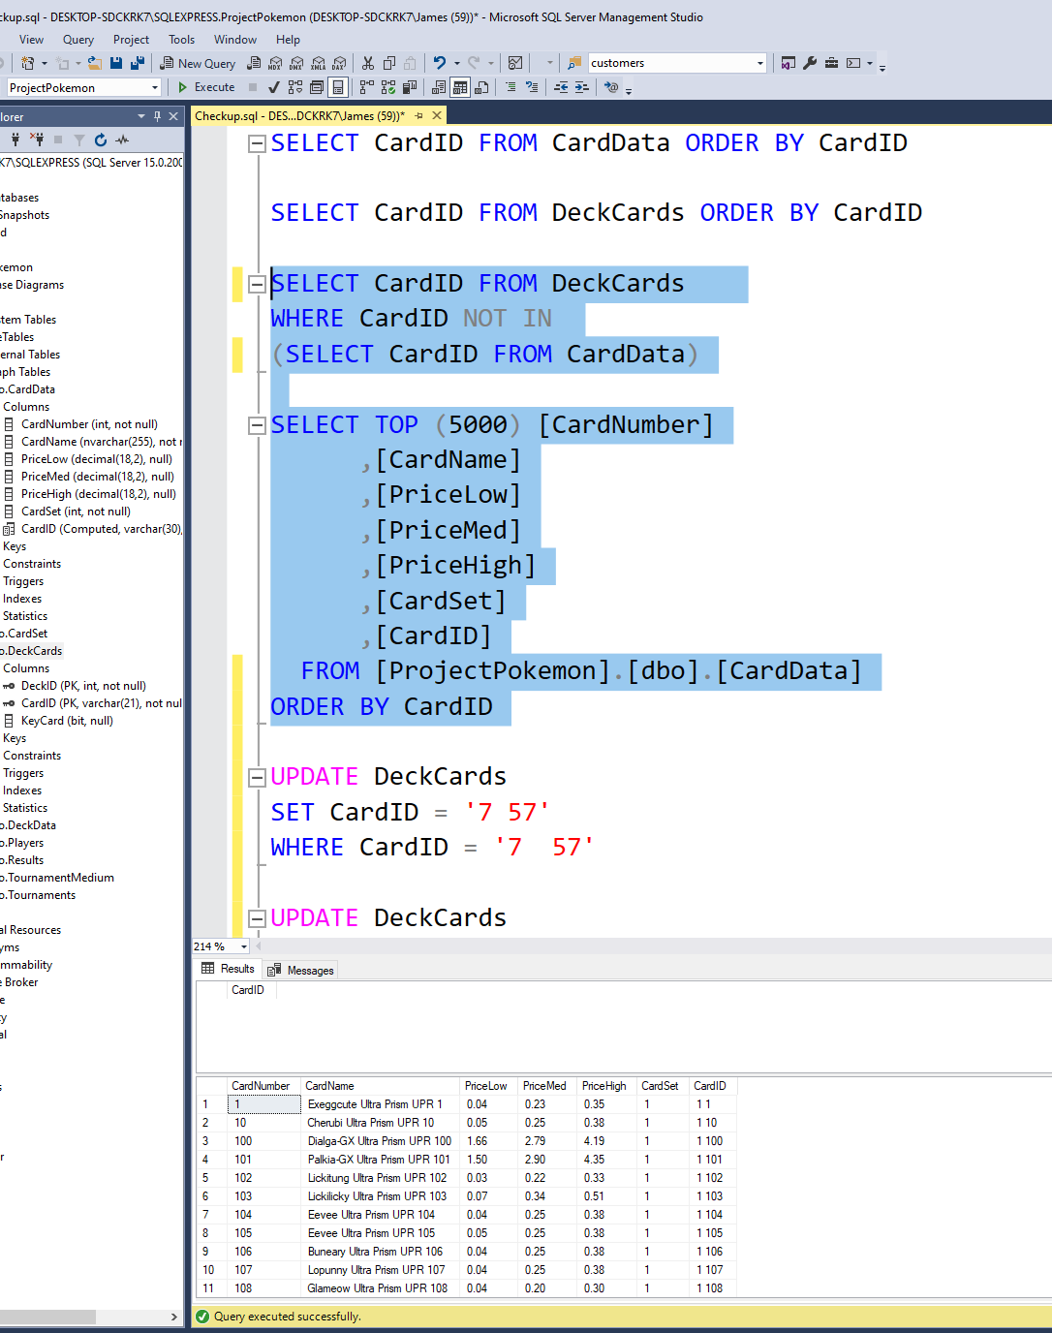

Success

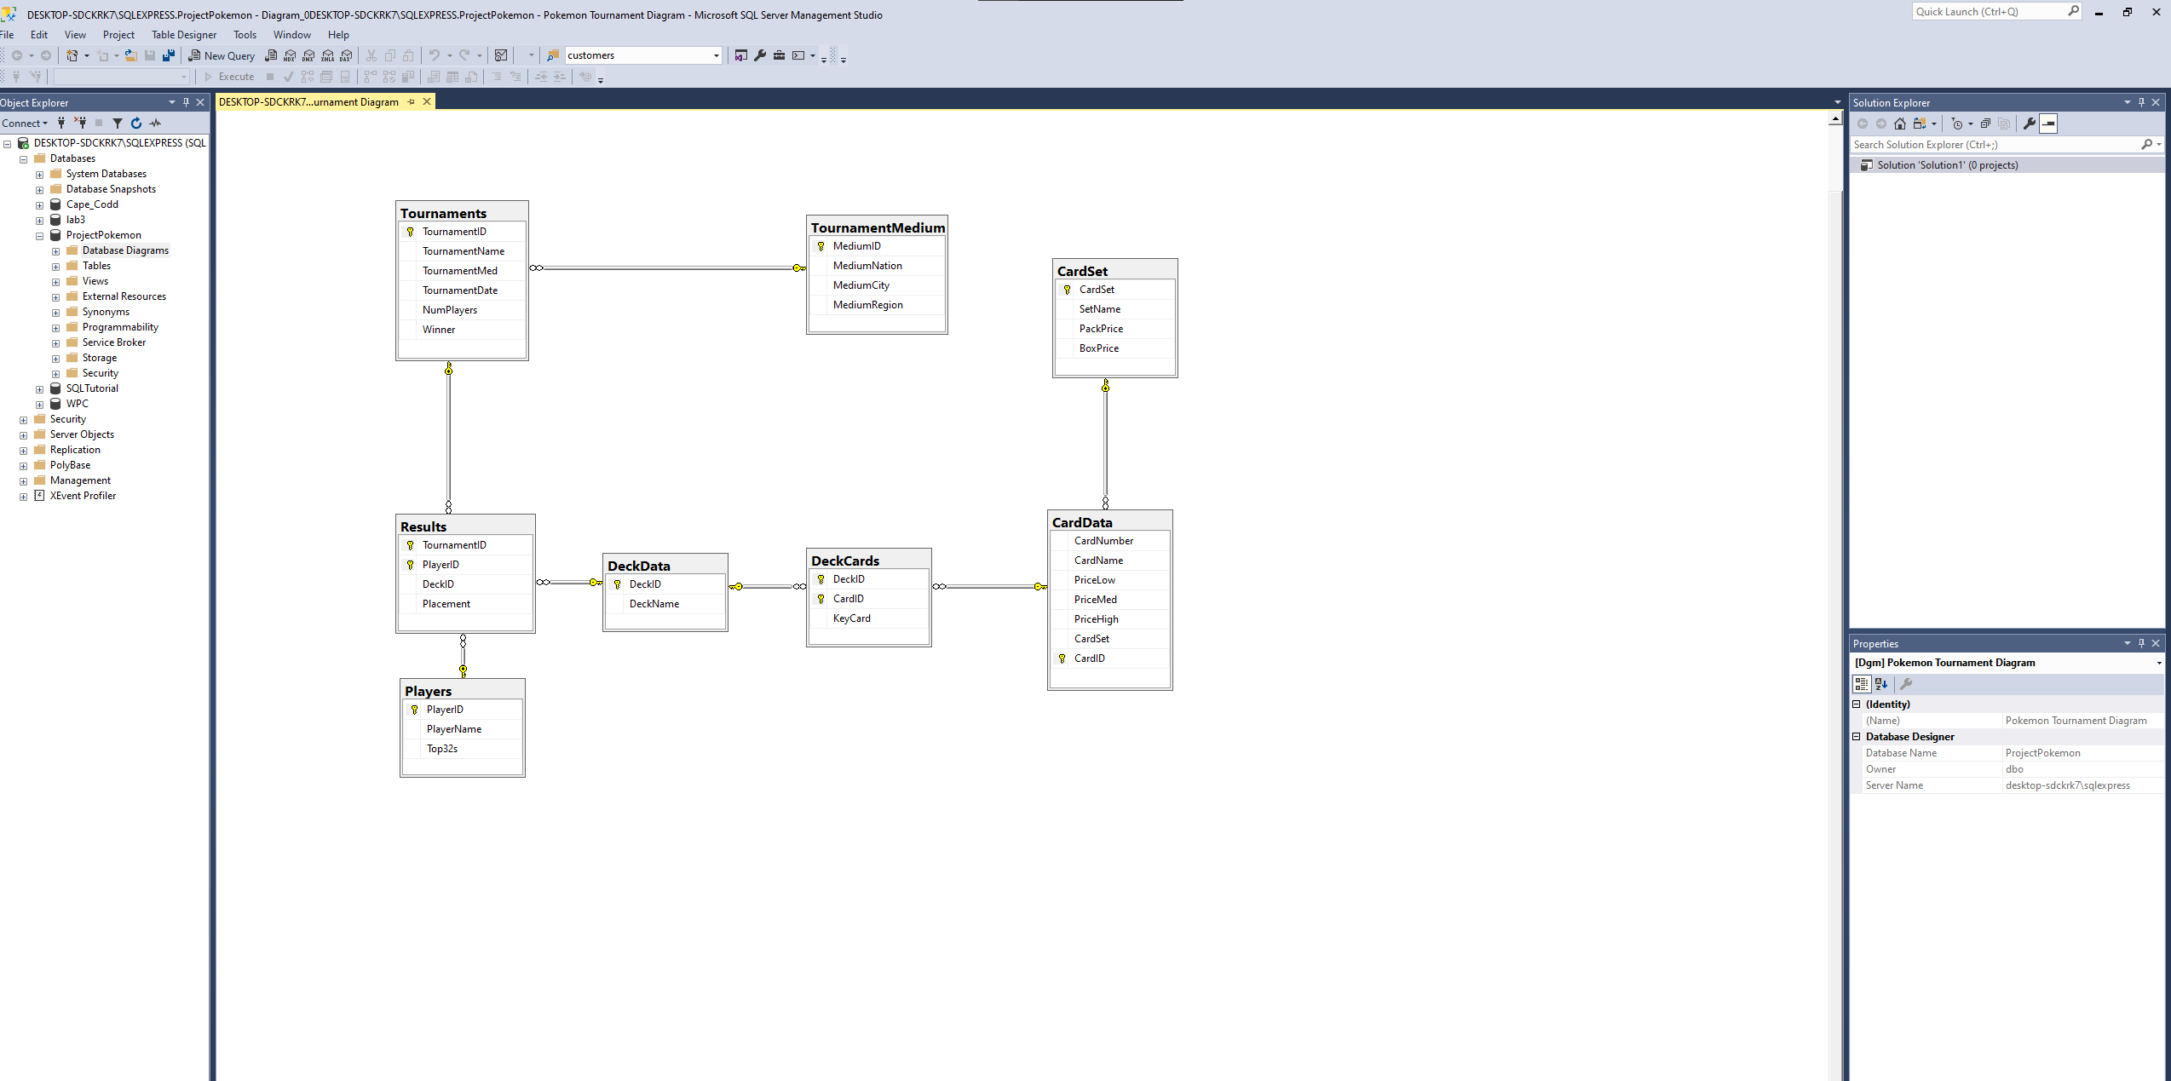

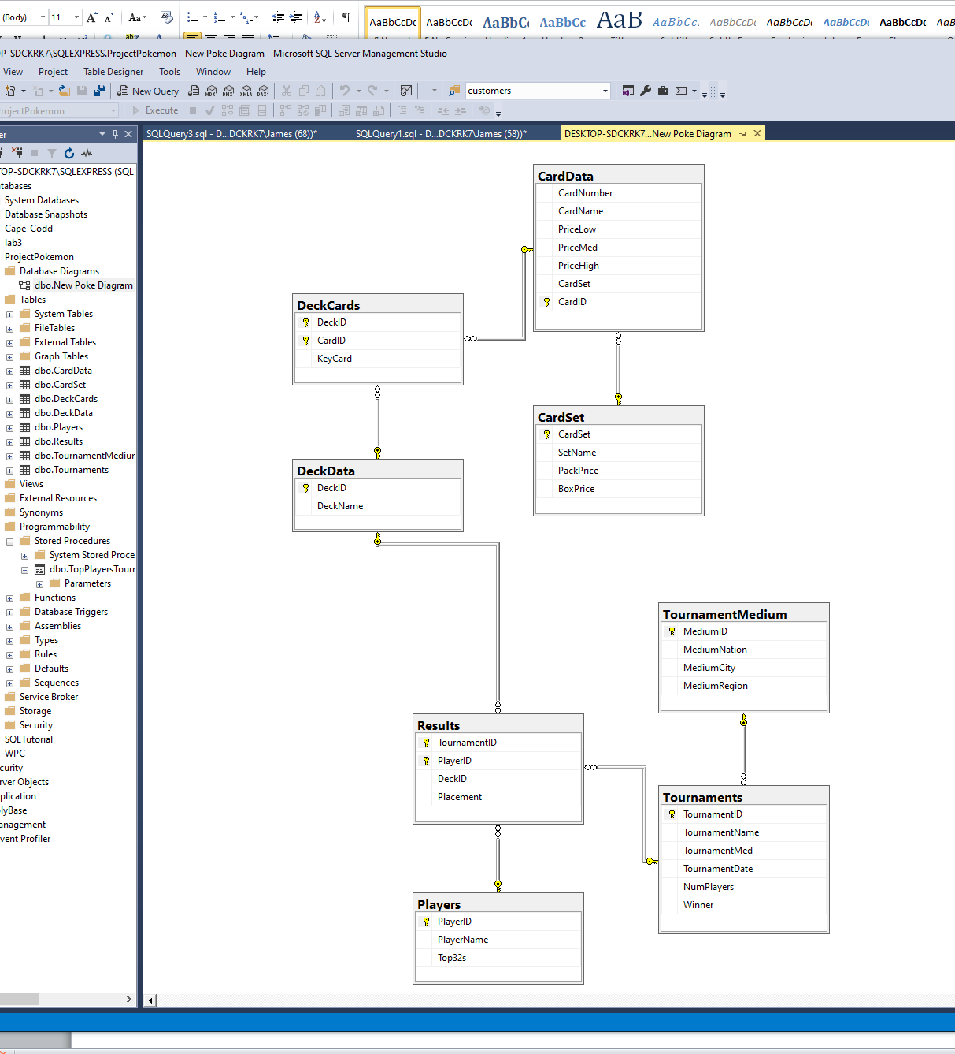

Finalized Diagram –TY SERVER TEAM

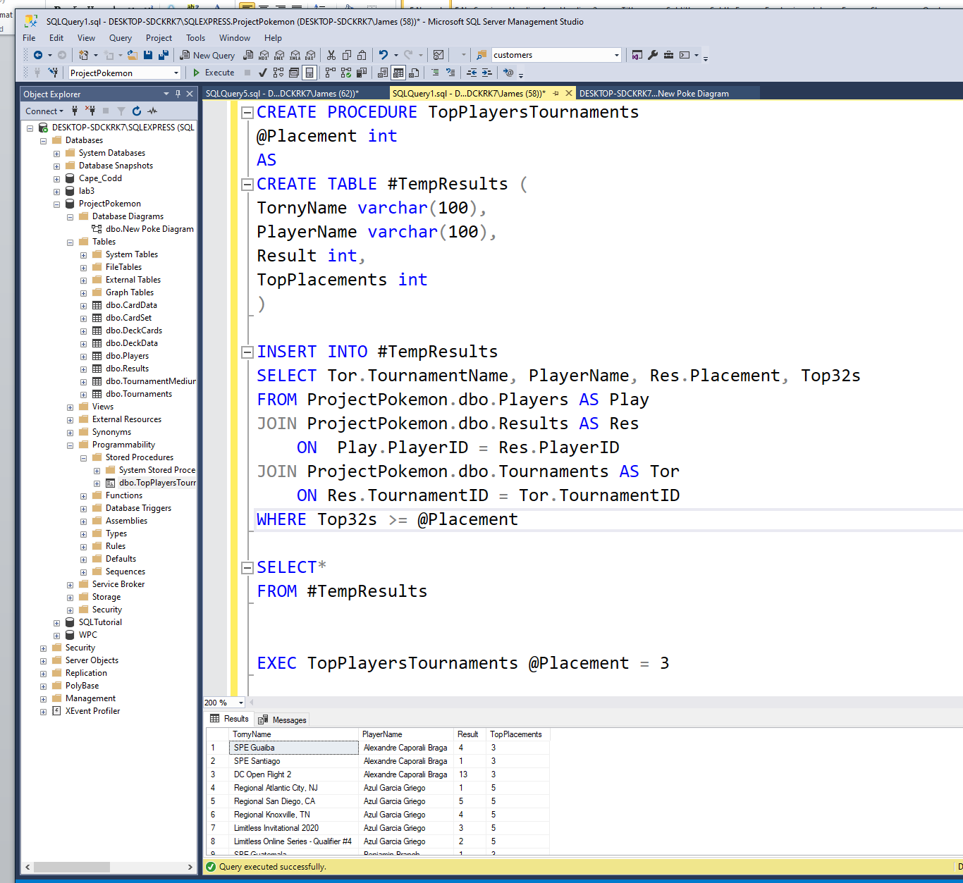

First stored procedure based on given value: “I want to see all the players who have had 3 or more top 32 placements, the tournaments they have placed in, and the result they got in that tournament.” This joined three tables and placed the results in a temp table.